IHRDC

GRADUATE ENGINEER
DEVELOPMENT PROGRAMME
MECHANICAL DISCIPLINE

SUBMERSIBLE PUMPS

Total Pages (60)

Submersible Pumps

Graduate Development Programme Module (M – 04 )5D
This Module is designed for AFPC existing Mechanical Graduates to provide understanding and hands-on experience on the submersible pumps.
This Module focuses on the principle of operation, construction of the pump, impeller adjustment, bushings, seals, disassembly, inspection, assembly and troubleshooting.
- Principle of operation.
- Impeller adjustment.
- Disassembly, inspection and check clearances.
- Assembly.
- Pump performance.
- Troubleshooting.

Audience :  Prerequisites :  Location :  Format : | Mechanical Graduates.  English comprehension and communication.  AFPC Training Center, D. Z.  Lecture, discussion and workshop practices.
This module is one of thirteen modules, which together cover the theoretical aspect of the Technical Training for the AFPC Mechanical Graduates Development Programme. This programme has been developed specifically for AFPC Graduate Development to enhance the dynamic Nationalization drive adopted by the company.

SAFETY REQUIREMENTS

1. GENERAL

Participant must become thoroughly familiar with the following safety requirements and first aid procedures, and must observe the safety requirements at all times. Maximum safety of personnel is of primary importance, followed closely by protection of equipment from damage. Careful observation of these safety requirements will minimize hazards or injury to personnel and equipment.

There are three types of Safety Requirements: Warning, Cautions, and Notes, which are intended to emphasize critical information. Safety Requirements also include procedures to be observed in the event of certain operating malfunctions and important precautions to be observed when personnel are working in a special environment (such as in an explosive atmosphere) or with a special substance.

Warnings, Cautions, and Notes are listed in order of significance as follows:

WARNING

A WARNING points out a procedure, practice, condition, or precaution which, if not heeded, could result in personal injury or loss of life.

CAUTION

A CAUTION points out a precaution which, if not observed, could result in damage or destruction of equipment.

Note

A Note highlights information necessary to understand or follow a procedure, practice, condition, or description.

2. COURSE SAFETY REQUIREMENTS

Participant has to use the following safety precautions during this course:
- Coverall.
- Safety helmet.
- Safety shoes/boots.
- Leather gloves.

Course Contents

Course Objectives. | 5
Course Outline. | 6
Equipment/ Resources. | 9
Course Manual. | 10
Training Aids. | 47
Lesson Plan. | 48
Course Final Test. | 55

Course Objectives:

Upon completion of this course, the trainee should be able to:-

Section One: Vertical Turbine Pumps and Propeller Pumps.

Understand the principle of operation.

Understand vertical turbine pump components.

Understand can turbine pump components.

Understand propeller turbine pump components.

Understand types of bearings and wear rings.

Section Two: impeller Adjustment.

Perform driver alignment.

Perform impeller adjustment for solid shaft driver.

Understand impeller adjustment for Hollow shaft driver.

Section Three: Vertical Turbine Pump maintenance.

Perform assembly and disassembly.

Demonstrate assembly and disassembly for a volute pump.

Understand trouble shooting.

Understand pump performance.

Course Outlines:

This course is designed for AFPC existing mechanical technicians, provide understanding and hands-on experience related to submersible pumps.

Duration of the course is five days (30 Hrs) the maximum number of participants shall be four in one batch.

This course to be conducted at AFPC training center classroom and assembly workshop.

Course Time Plan:-

Instrument Time 10

Workshop Time 14

Final Test Time 6

Day-1 (6 Hrs)

Time (Hrs) | Activity | Location
2  1.30  2  .30 | Vertical turbine pumps and propeller pumps.  vertical turbine description.  Can turbine pumps.  Submersible turbine pumps.  propeller turbine pumps.  Vertical turbine pump bearings.  Wear ring repairs.  Impeller adjustment for vertical turbine pumps.  2.1 Driver types.  2.2 Driver alignment.  - Assessment | Classroom

Day-2 (6 Hrs)

Time (Hrs) | Activity | Location
1.30 | 2.3 Impeller adjustment- general.  2.4 Semi-open impeller re-adjustment chart.  2.5 hollow shaft driver, impeller adjustment.  2.6 solid shaft driver, impeller adjustment. | Classroom
2  2 | Driver alignment.  Impeller adjustment. | Workshop
0.30 | - Assessment.

Day-3 (6 Hrs)

Time (Hrs) | Activity | Location
1 | Vertical turbine pump. Maintenance  Bow/ assembly.  Column assembly.  Discharge head assembly.  Installation and maintenance. | Classroom
4.30 | Vertical turbine pump repair.  Assembly procedure.  Disassembly.  Impeller assembly method. | Workshop.
0.30 | - Assessment.

Day-4 (6 Hrs)

Time (Hrs) | Activity | Location
1.30 | 3.7 Troubleshooting and performance curve.  3.8 vertical wet-pit cantilever type-volute pump. | Classroom
4 | Disassembly of vertical wet-pit cantilever  volute pump. | Workshop.
0.30 | - Assessment.

Day-5 (6 Hrs)

Time (Hrs) | Activity | Location
1 | Final Test | Classroom
5 | Final Test (Practical) | Workshop

Equipment and Resources:

Vertical turbine pump (Johnston Type).

Vertical Wet-pit cantilever- type volute pump.

Over-head crane.

Hand tool box.

Measuring tools.

4- Course Manual

(Hand Out for Participant)

Section-I

1-Vertical Turbine Pumps and Propeller Pumps

The Principle Of Operation

- The common physical configuration of the vertical turbine pumps are:

- Line shaft turbines (vertical turbine pump)
- Can turbine.
- Submersible turbine.
- Propeller turbine.

- Line shaft turbines description (vertical turbine pump)\

Line shaft turbines are composed of four major parts, starting at the bottom of the illustration:

- The pumping unit (Bowl assembly)
- The water column.
- The discharge head.
- The motor or drive unit.

    - The pumping unit consists of a bowl assembly and a suction bell. Fluid enters the pumping unit at the suction bell. It then passes to the bowl assembly, which consists of an impeller and a bowl or casing. The bowl surrounds the impeller and serves the same function as the volute of an end-suction centrifugal pump.

    - If the pump contains more than one bowl the pumped fluid passes upward through each bowl assembly. The amount of energy and pressure added to the fluid is directly proportional to the number of bowls. For example, if one bowl produces 50 psi, then two bowls will produce 100 psi, and three will produce 150 Psi.

    - The amount of fluid pumped is not changed by the addition of pump bowls. The amount of fluid a pump can handle depends upon the capabilities of the first impeller.

    - The ability to add bowls to obtain high pressures makes this kind of pump very popular for use in deep wells in industry, irrigation, and municipalities.

1.1.5- The entire bowl assembly of a lineshaft turbine is usually submerged. Fluid
travels from the bowl assembly through the water column. The column
contains the drive shaft and radial bearings. These bearings help to keep the
shaft aligned. They can be made of bronze or rubber.

    - Rubber bearings are usually water lubricated. Bronze bearings are usually oil lubricated. The oil-lubricated bearing generally works better in deep wells (over 300 ft).
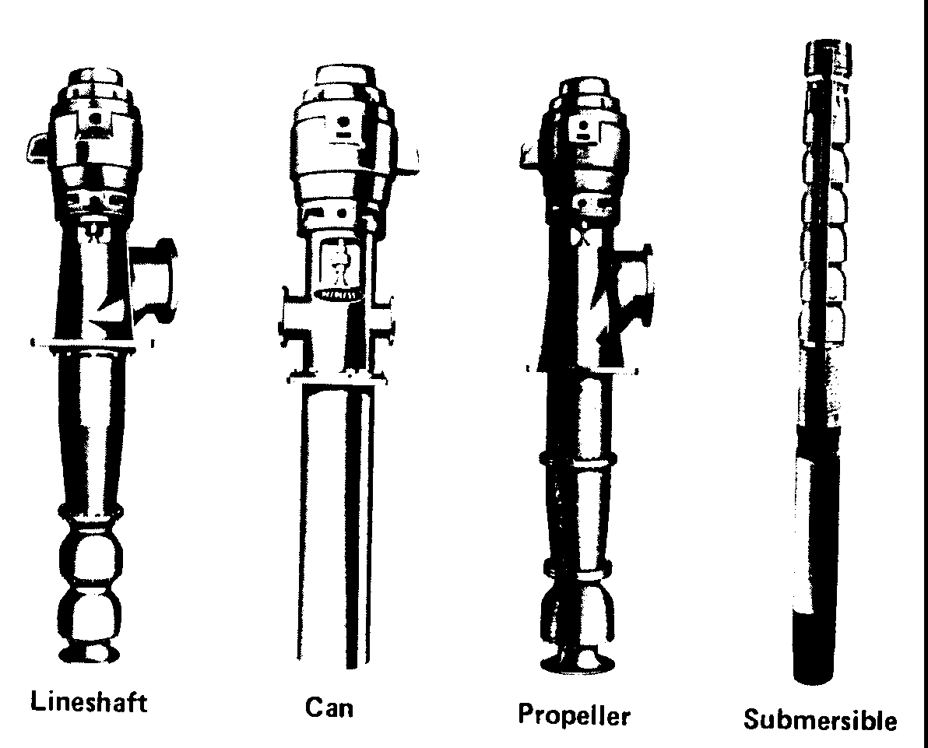

Common Vertical Turbine Pumps

Vertical Turbine Pump

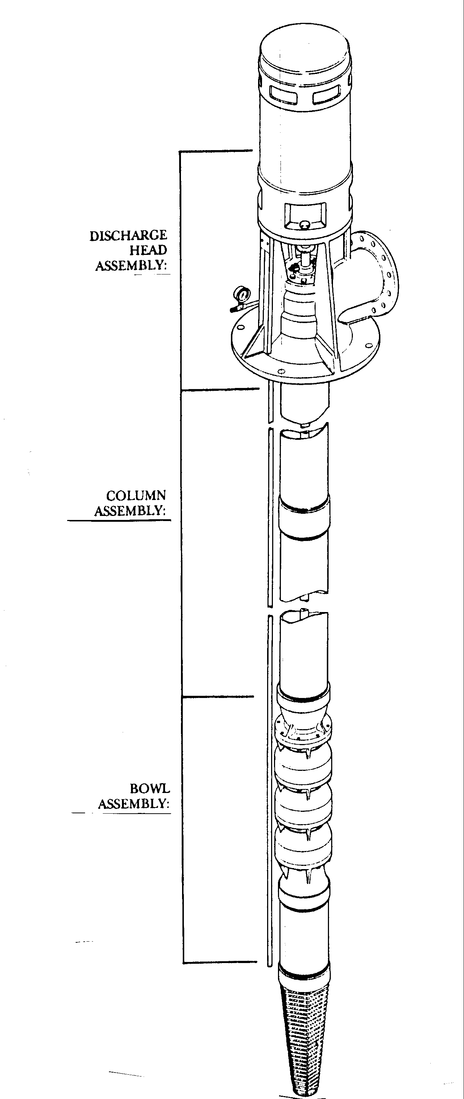
Product-lubricated Pump

Mixed-flow Bowl Assembly with Lock Collet
(2 Stages Shown)

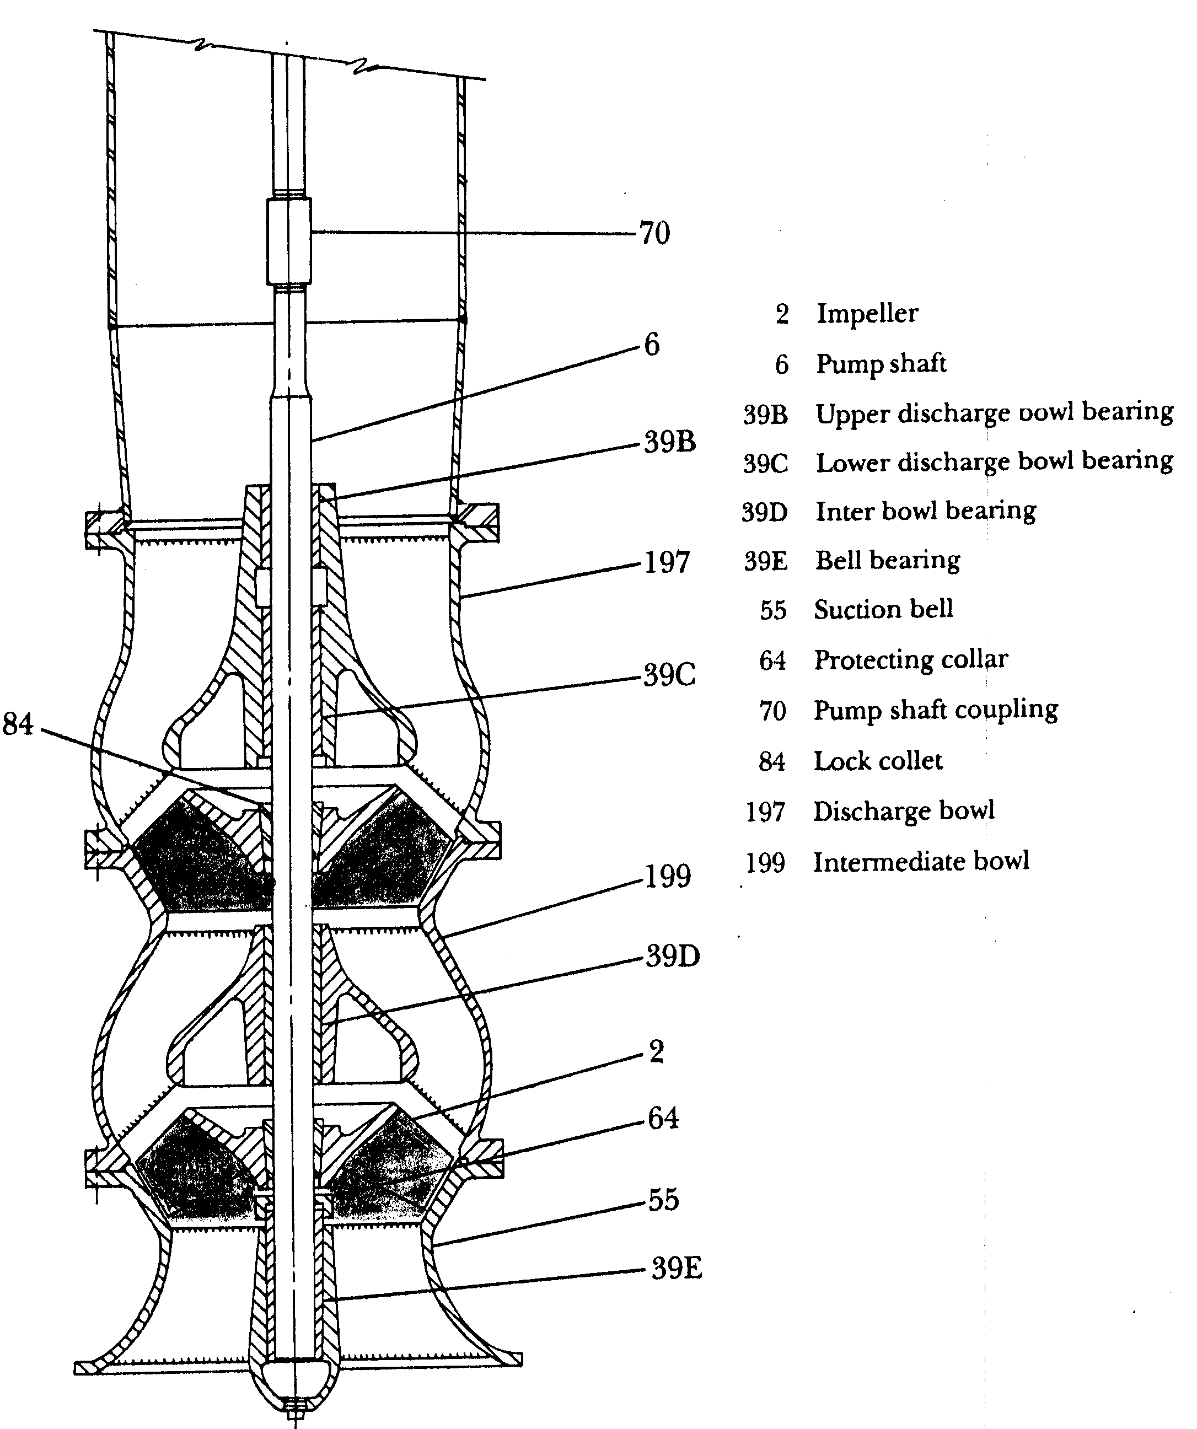

1.1.7- The column is secured to the discharge head. The pump discharge piping is
connected to the discharge head. The discharge head contains the stuffing box.
In water-lubricated pumps, the stuffing box contains either packing or a
mechanical seal. Either can be used to control leakage around the shaft.

1.1.8- The motor is located above the discharge head. The common practice is to use
hollow shaft motors on lineshaft turbines. The pump drive shaft passes through the motor shaft and is secured to the top of the motor by the head nut. This arrangement places the entire load of the drive shaft and impellers on the top bearing of the motor.

1.1.9- The motor's top bearing is referred to as the thrust bearing and is often a
spherical-roller thrust bearing. The bottom bearing in this type of motor is commonly called the radial bearing. It is usually a single-row, deep-groove ball bearing.

1.1.10- The impellers used most often in lineshaft turbine pumps are either closed or
semi open. The semi-open impeller can be raised or lowered after pump installation to alter the pump capacity and discharge pressure. This adjustment is made by adjusting the head nut. It is for this purpose that the hollow-shaft motor was designed.

1.1.11- Adjustment of the impeller setting on semi-open impeller pumps can be
critical. On one particular pump, for example, a change of 0.001 in. on the head nut can alter the discharge head 10 ft.

Can Turbines Pumps

    - The can turbine is an adaptation of the lineshaft turbine. It is often used as a booster pump, especially in municipal water systems. A can turbine pump is shown. In this design, a lineshaft turbine is placed inside a metal or concrete "can". Fluid enters the can under pressure. The pump simply moves the fluid out of the can at a higher pressure.
    - The incoming fluid is fed down into the can. The turbine inside the can pumps the fluid up and out the discharge port.
    - Vertical Can Pump Description (V.C.P)

A. General Description
The basic components of the VCP pumping unit are the suction can, discharge head assembly, pump bowl assembly, column assembly, mechanical seal, driver, and spacer coupling

B. Column Assembly
The column assembly, if required, consists of the column pipe, shaft, and bearings. (The column assembly is not required on all pumps.) The column assembly carries the pumped liquid from the bowl assembly to the discharge head.

C. Bowl Assembly
The bowl assembly consists of the impeller mounted on the bowl shaft, the bowls, the suction bell (first stage only), and bearings. (Note: A tie-down bolt in the bottom of the suction bell is used to secure the bell to the shaft. Remove before installation.)

D. Discharge Head Assembly
The discharge head supports the pump bowl assembly and driver. The discharge and suction connection are on the discharge head.

E. Mechanical Seal
The VCP pump can be equipped with a single, a tandem, or a double mechanical seal.

F. Driver and Drive Coupling
The VCP pump is designed to minimize axial thrust, thereby permitting the use of an in-line motor. The coupling is a rigid spacer type coupling, which allows the removal of the mechanical seal, seal sleeve, and stuffing box without removal of the driver.

1.2.4 VCP Adjustments:
- Axial Adjustment

Turn the adjusting nut until the gap between the top of the spacer and the top half coupling is a minimum of 1/8" or a maximum of one-half the total pump bowl axial end play. Then continue turning until its mounting holes are aligned with those in the bottom half coupling and spacer. Pull the bottom half coupling and spacer up against the adjusting nut. Install the lower Set of bolts and tighten evenly. Turn the top half coupling until its holes are aligned with those in the mating spacer flange. Install and tighten each bolt a little at a time until face contact is made, making certain that the registers engage properly.

NOTE: Each complete turn of the adjusting nut represents in axial adjustment 3/32” for 7/8”, and 1” shafts, and 1/8” for 1-3/16” and larger shafts.

2-Impeller Adjustment

1. When starting the impeller adjustment, the impellers must be down against the bowl seat.
2. Raise the impeller 1-1/2 to 2 turns of the adjusting nut, or approximately 1/8”.
3a. If, after making the adjustment, the pump does not deliver its rated capacity, the impellers can be lowered one step at a time until the lowest possible adjustment is achieved without the impellers dragging.
3b. If, after making the adjustment, the impellers appear to be dragging, the unit should be stopped and the impellers raised one step.

Note: The impeller adjustment must be made prior to the seal adjustment.
Can Turbine Pump
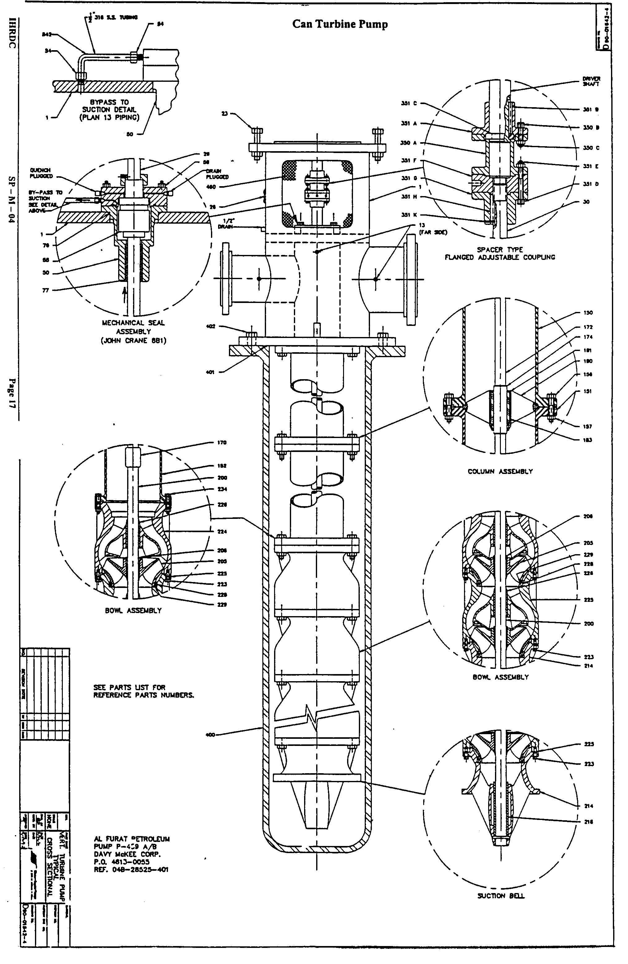
2-Spare Parts List (P-459 A/B)

NO. REQ. D. | PART NAME | MATERIAL | REF. NO.
1 | “VC” Discharge Head | FAB. STL. | 1
2 | Coupling Guard | PERF. SS | 460
2 | Banding & Buckles | SS | 462
1 | Pipe Plug | Steel | 13
1 | Coupling FLG’D ADJ. | Steel | 350
1 | Key Motor | Steel | 351 B
1 | Key Pump | Steel | 351 H
1 | “O” Ring | BUNA N | 401
1 | Rotation Arrow | ALUM | 26
1 | 200 HP US Motor VSS. | 880 VOLT. TEFC
1 | Housing Seal | 316 SS | 50
1 | Bushing MS Thrtle | 937 BRZ | 61
1 | Ring O (Housing) | BUNA N | 76
1 | ASM Mech. Seal | 6 ASSEMBLY | 55
1 | Slinger | NEOPRENE | 99
2 | Tube Bypass | 316 S.S. | 542
1 | Shaft Head | 316 S.S. | 30
1 | Gasket Top COL | VELLUMOID | 17
1 | Pipe Top COL | STEEL | 150
1 | Pipe BTM COL | STEEL | 152
1 | Retainer Bearing | 316 S.S. | 180
1 | Bearing, Lineshaft | NEOPRENE | 183
1 | Ring, Snap | 632 SS | 181
1 | Shaft Pump | 316 SS | 200
1 | Coupling Line Shaft | 316 STL | 170
 | Bowl Inter 18 NX | DI FUSECOTED | 225
2 | Bearing Bowl | RBR W/SS SHELL | 226
1 | Bowel Bottom 18 NX FOR | DI FUSECOATED | 225
1 | Ring Bowl Wear | 316 SS | 228
1 | Ring IMP Wear | 316 SS | 229
1 | Impeller 18 NX 4 | 316 SS | 205
1 | Collet Impeller | 316 SS | 206
1 | Impeller 20 NX 3 | 316 SS | 205
1 | Impeller Collect | 316 SS | 206
1 | Ring Bell Wear | 316 SS | 228
1 | Bearing Suction | RBR W/SS SHL | 216
1 | Bell Suction 18 NX FOR | CL 30 CT | 214

1.3.Submersible Turbines Pumps

1.3.1- Another version of the vertical turbine pump is the submersible turbine.
This kind of pump is used in many individual homes and in municipal and industrial wells. The pump portion of this unit is similar to that of the lineshaft
turbine. The major difference is that the motor is located under the pump instead of above it. The entire assembly is lowered into the fluid to be pumped. The fluid is used to cool the motor.
1.3.2- This pump's configuration eliminates the problems commonly associated with long drivelines and their bearings. It does cause other problems, however. If fluid enters the motor, the motor will fail. Also, you lose the ability to adjust the impeller clearance as you can with a lineshaft turbine.

- Classification due to the Flow Pattern

Vertical turbines can be classified also by flow pattern. The lineshaft turbine, can turbine, and submersible pump are all classified as mixed-flow pumps.

Mixed Flow Turbine Pumps

1.1-The fluid inside the pump does not flow straight up the shaft, as in an axial-flow pump.
1.2-The fluid inside the pump does not make a right-angle turn as it flows through the impeller.
1.3- Energy is transferred to the fluid being pumped in two ways-by centrifugal
force and by a wedging action.

2-Axial-Flow Propeller Pumps

2.1. Axial-flow propeller pumps are often used to supply water for municipalities and irrigation purposes. They are also used for pumping out ponds or areas having excess amounts of water. These pumps normally deliver a high volume at low head, and are supported from the drive area. A typical axial-flow propeller pump is shown.
2.2. The propeller pump bowl, as shown in cross section frequently resembles a short length of pipe. Generally, it is slightly smaller in diameter than the discharge pipe to which it is bolted. Often the pump bowl contains a set of diffuser vanes. The diffuser vanes reduce the stirring action caused by the pump propeller and thus straighten the flow of fluid into the discharge pipe.
2.3. In addition, the pump bowel contains one or two steady bearings. These bearings keep the shaft and impeller turning in a true line.
2.4. The suction bell is usually flared at the bottom. The bell might have diffuser vanes. Occasionally, an additional shaft steady bearing is built into the suction bell.

Submersible Turbine Pump Propeller Pump
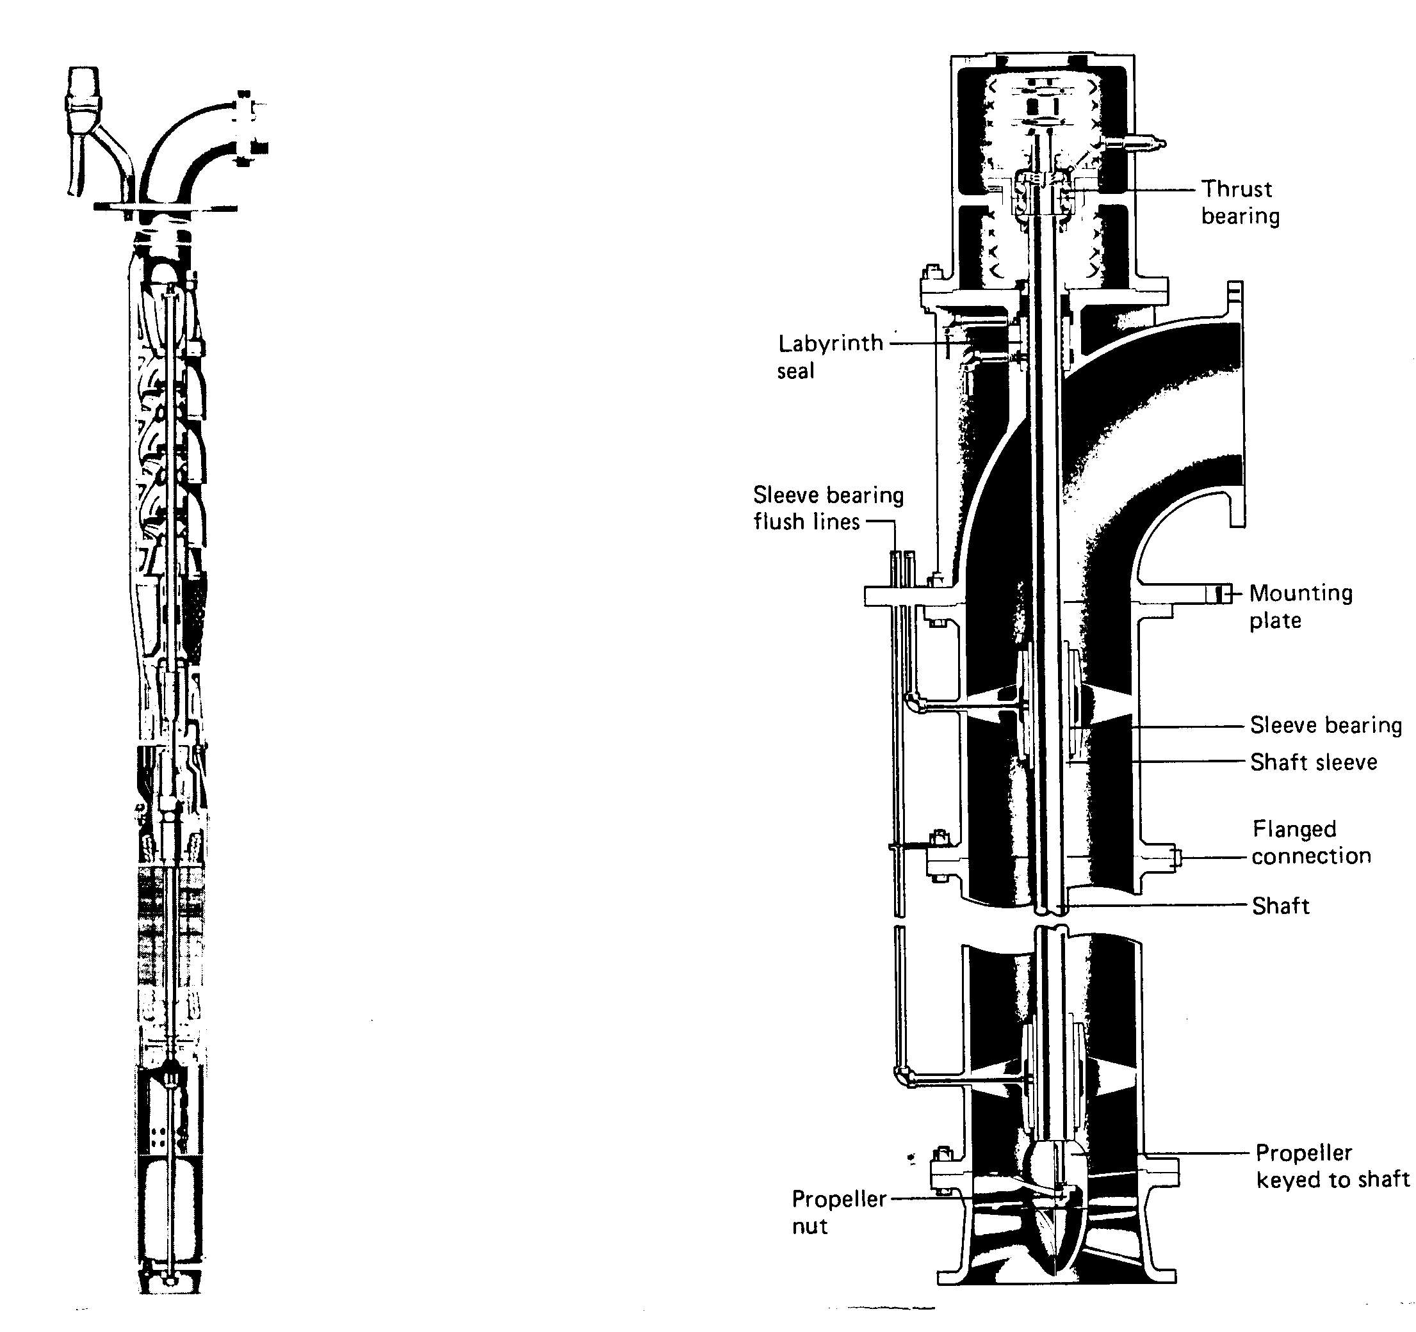

1.4.Propeller Turbine Pumps

1.4.1.Another major style of vertical turbine is called a propeller pump. Propeller
pumps can be classed as axial-flow or mixed-flow Pumps. Mixed-flow propeller pumps move fluid partly by centrifugal force and Partly by the lift of the blades or vanes on the fluid. Axial-flow propeller pumps move fluid only by the propelling or lifting action of the blades on the fluid.

1.4.2.The two separate designs, although they resemble each other outwardly, have
different operating characteristics. Both axial-flow and mixed-flow propeller pumps are commonly installed with the entire pumping unit submerged.

1.4.3. In applications involving high discharge heads, propeller pumps can be used in
double or triple stages. Each stage will have the same propeller design. In operation, diffuser vanes direct the fluid discharged from one impeller into the suction of the next stage. This action boosts the fluid's pressure and velocity until it overcomes the head.
1.4.4. Although small, fractional horsepower sump pumps are usually of the end- suction centrifugal type, the larger sump pumps for sewage and slurry applications are often propeller pumps. Propeller pumps can handle much larger volumes of fluid than can end-suction pumps and generally are driven by motors of 5 to 10 hp or more.

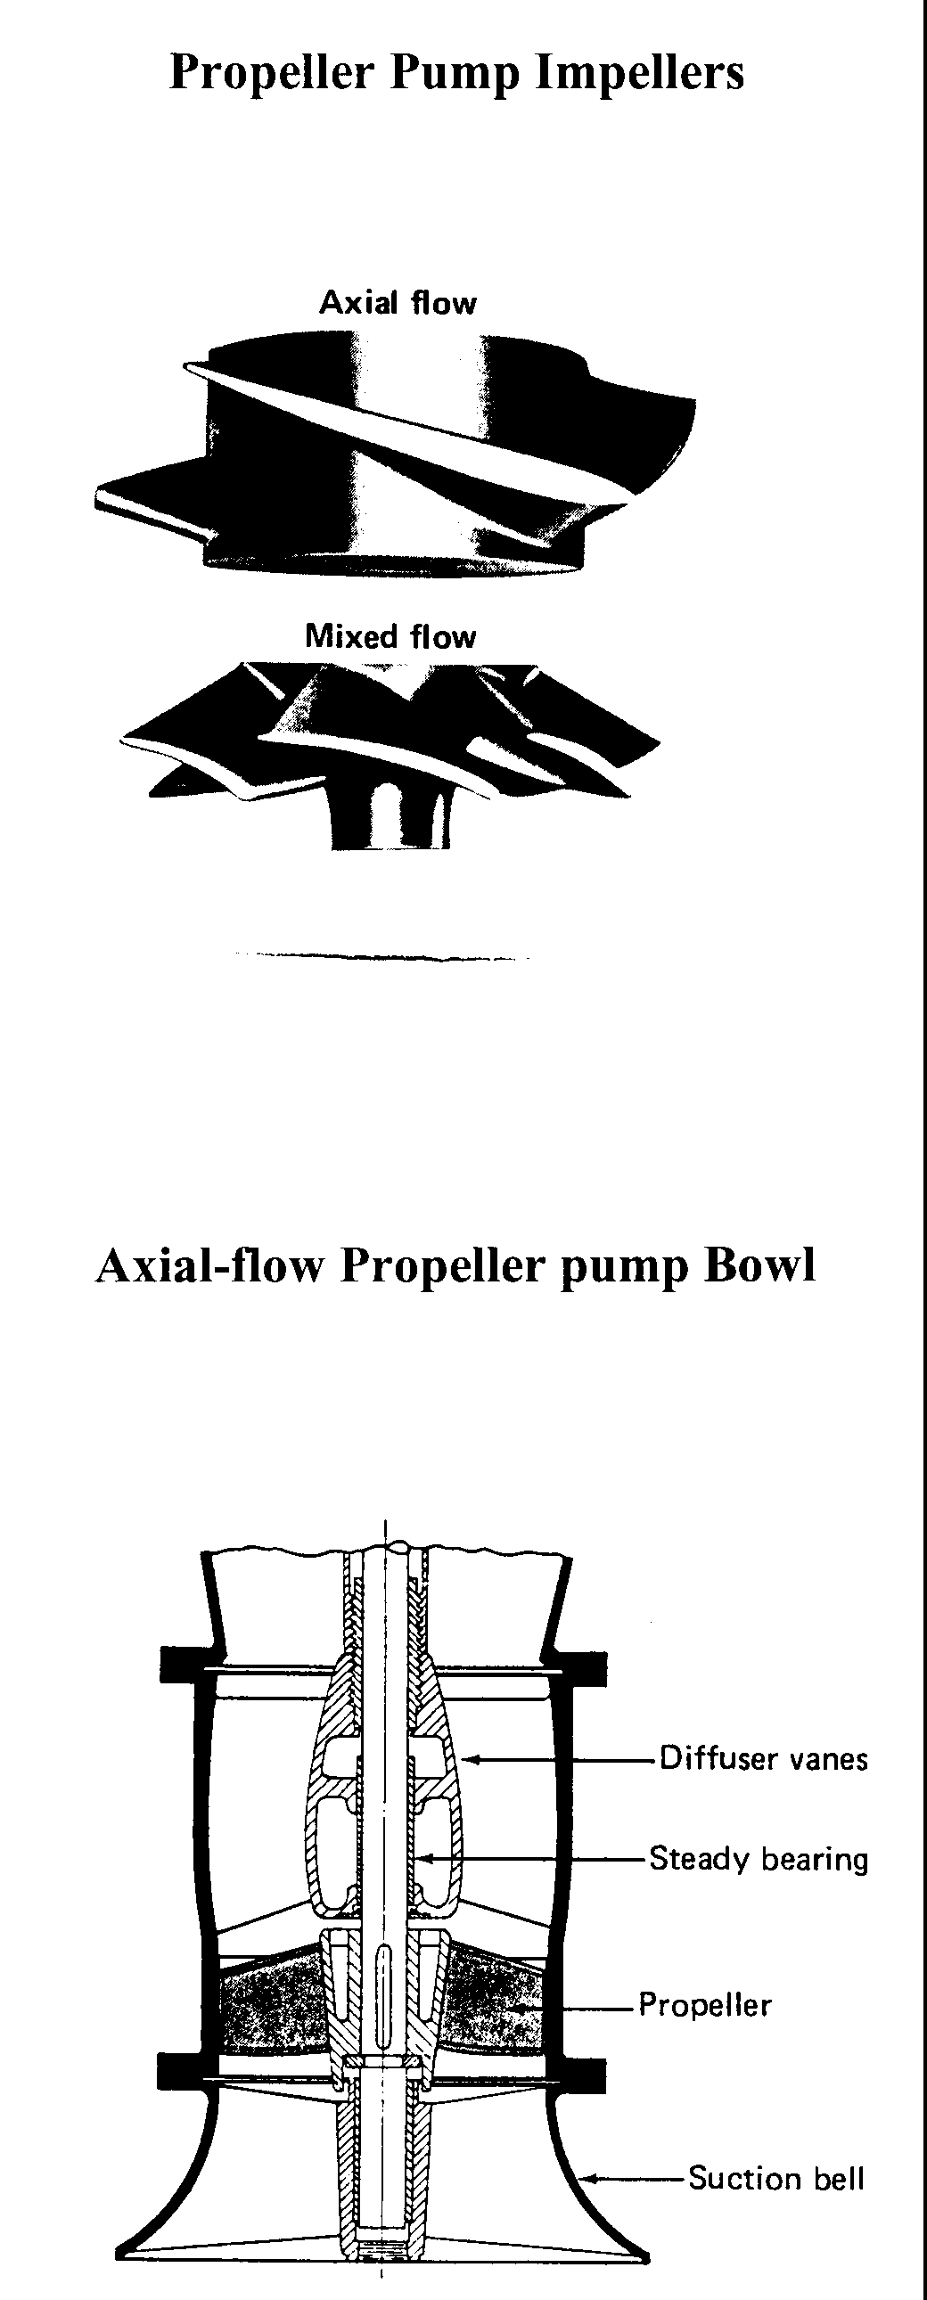

Product-lubricated Pump

Propeller-product-lubricated Bowl Assembly with Thrust Ring
(2 Stages Shown)

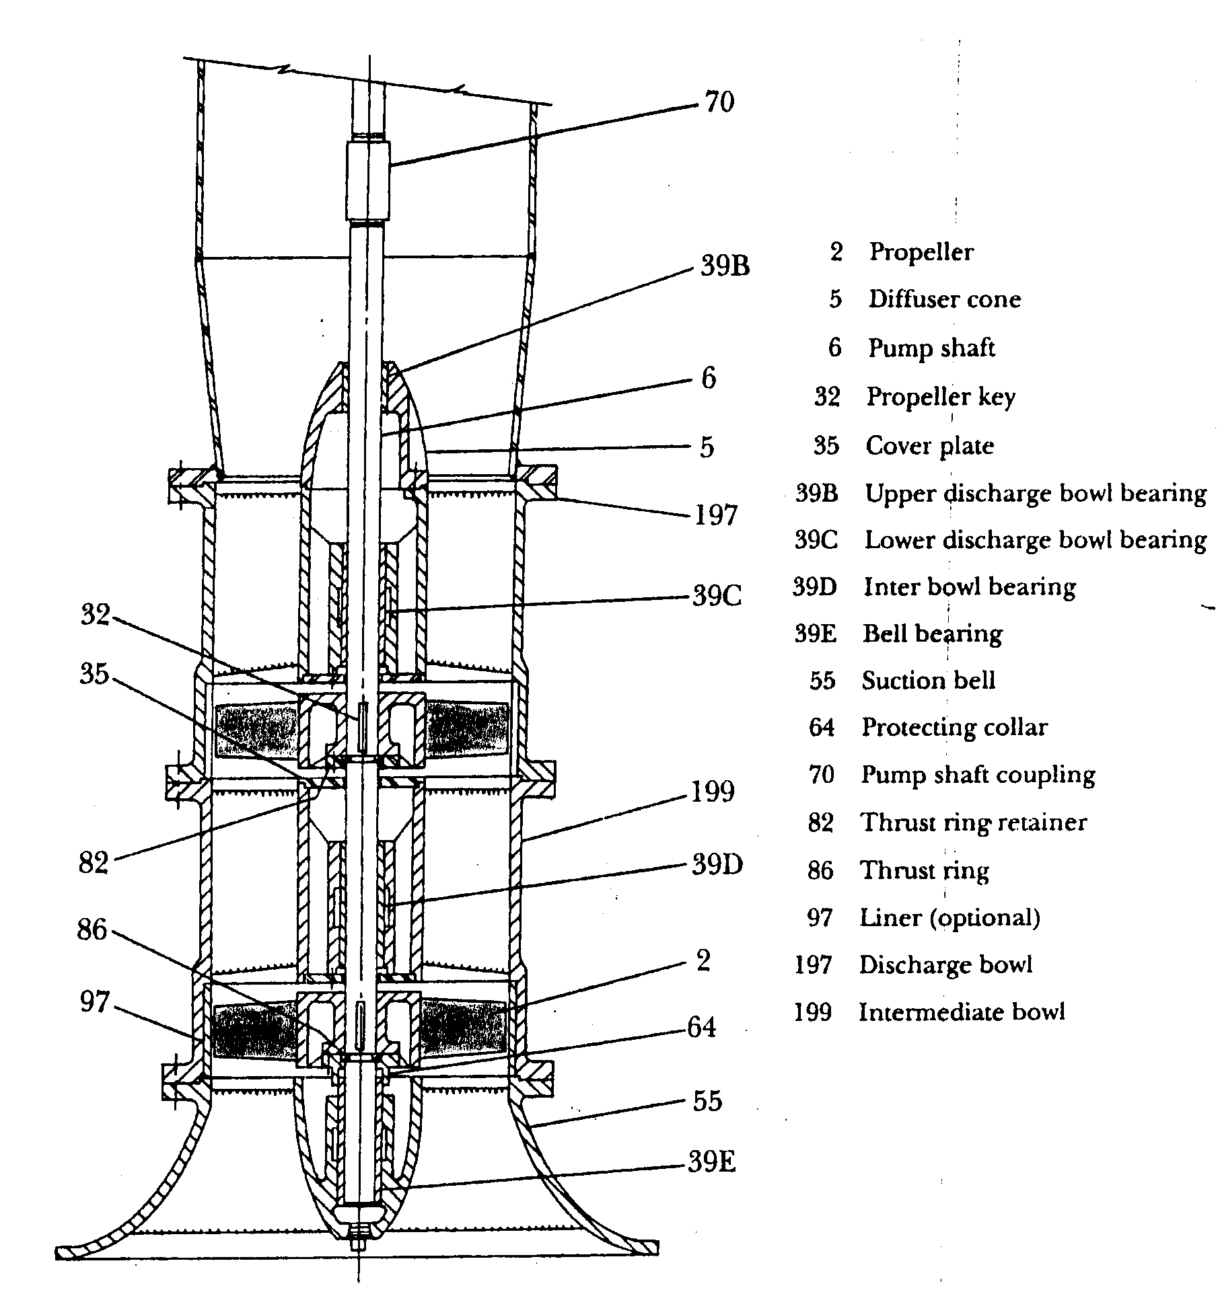

1.5. Vertical Turbine Pump Bearings

1.5.1. Graphalloy / Bearings

Product lubricated bearings in clean liquids can be upgraded to a material such as Graphalloy. Graphalloy is a solid carbon graphite, the pores of which have been impregnated with molten metal in a high heat and high-pressure process. During the impregnation process the metal permeates the graphite in long continuous metal filaments. It is these filaments which give Graphalloy its ductility, high strength and good heat dissipating properties. The metal increases its strength and ductility and removes heat generated at the bearing surface. Graphalloy contains no oil and does not produce any toxic emission, which may contaminate the pumped product. It is extremely durable in clean products Graphalloy bearings operate well at temperatures from – 50ºF to + 300ºF in fresh or salt water, gasoline, jet fuels, solvents, bleaches, caustics, dyes, liquefied gases, acids.

1.5.2.Installing Graphalloy Bearings

The preferred method for installing Graphalloy bearings utilizes an arbor press or hydraulic press as shown. The bearing or the bore into which the bearing is installed should have a 1/32 in. minimum x 45º chamfer to facilitate entry of the bearing. A stepped mandrel or arbor should be used to ensure that the bearing will be positioned straight with the hole before installation. The small outside diameter of the arbor should be 1/16 in. smaller than the inside diameter of the bearing, and the large outside diameter of the arbor should be larger than the outside diameter of the bearing. The pressing motion must be continuous with no interruption until the bushing is completely in place. As an alternative, the bearing may be pressed into the housing by the bolt-and-nut method; that is, with a plate against the upper end of the bushing as shown. The nut must be continuously drawn up.

Check all bearings for total clearance over the shaft diameter. It is recommended that all bearings indicating wear be replaced. The following indicates the maximum allowable diametrical clearance over existing shaft diameter:

1 " through 13/4" shaft - .020” clearance
115/16" through 2 7/16” shaft-.025" clearance
2 11/16" through 3 15/16 "shaft-. 030” clearance

All bearings are pressed into their respective bores and can be either pressed out or machined on the inside diameter.

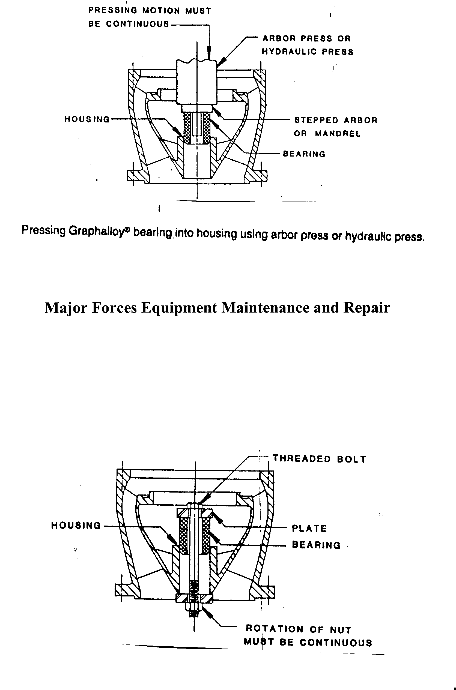

Bolt-and-Nut Method of Pressing Graphalloy Bearing into Housing

1.5.3.Special Bearings

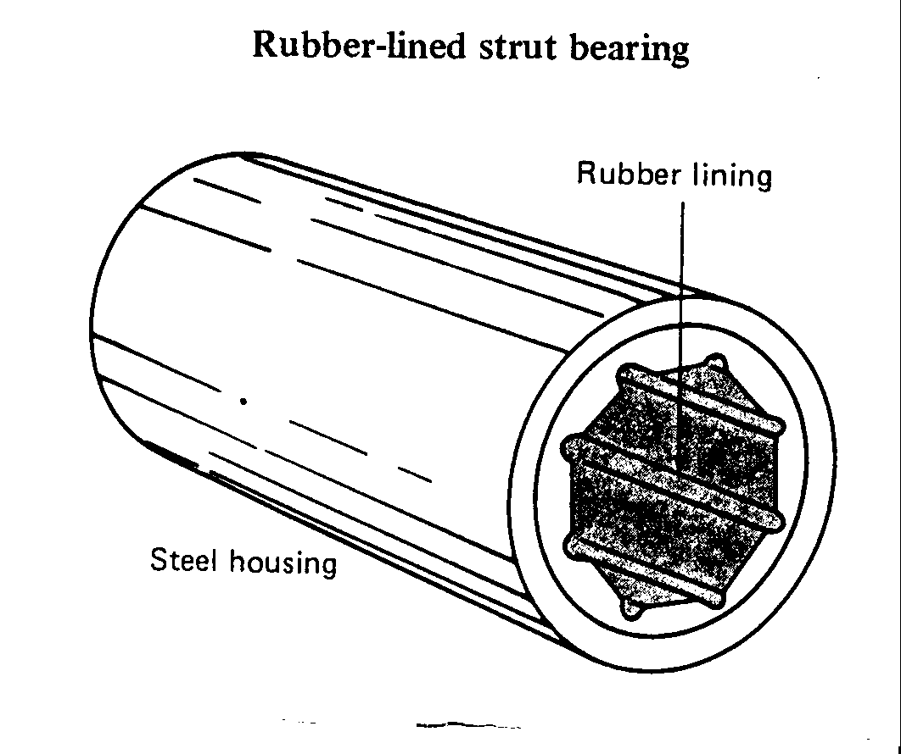
Many vertical turbine pumps use a special rubber-lined strut bearing as an intermediate shaft support. As shown the bearing outer case is made of metal and the inner bearing surface is made of rubber. The area of contact with the shaft is small, but is sufficient to withstand the load. The bearings are lubricated by the fluid being pumped. Because of their design, these bearings offer excellent resistance to abrasion.

1.5.4 Lead- Bronze Bearing

High-lead bronze bearing is used in vertical turbine pump suction case, and normally packed with water proof grease.

1.6-Maintenance and Repair Wear Rings

Vertical turbine pumps components are available as a complete bowl assemblies and spare parts. When service is required, the impeller wear surface can be turned to a predetermined diameter and the bowl machined to receive wearings of matching dimensions. Original clearance is restored by installing only one wear ring per stage.

As is the case with bowl bearing, the wear ring have differential pressure across them and will act as bearing provided that they are not grooved. Grooved wearing rings should only be used in the case the product contains abrasive materials. Wear rings material normally aluminum- bonze and shrink-fitted to the impeller skirt.
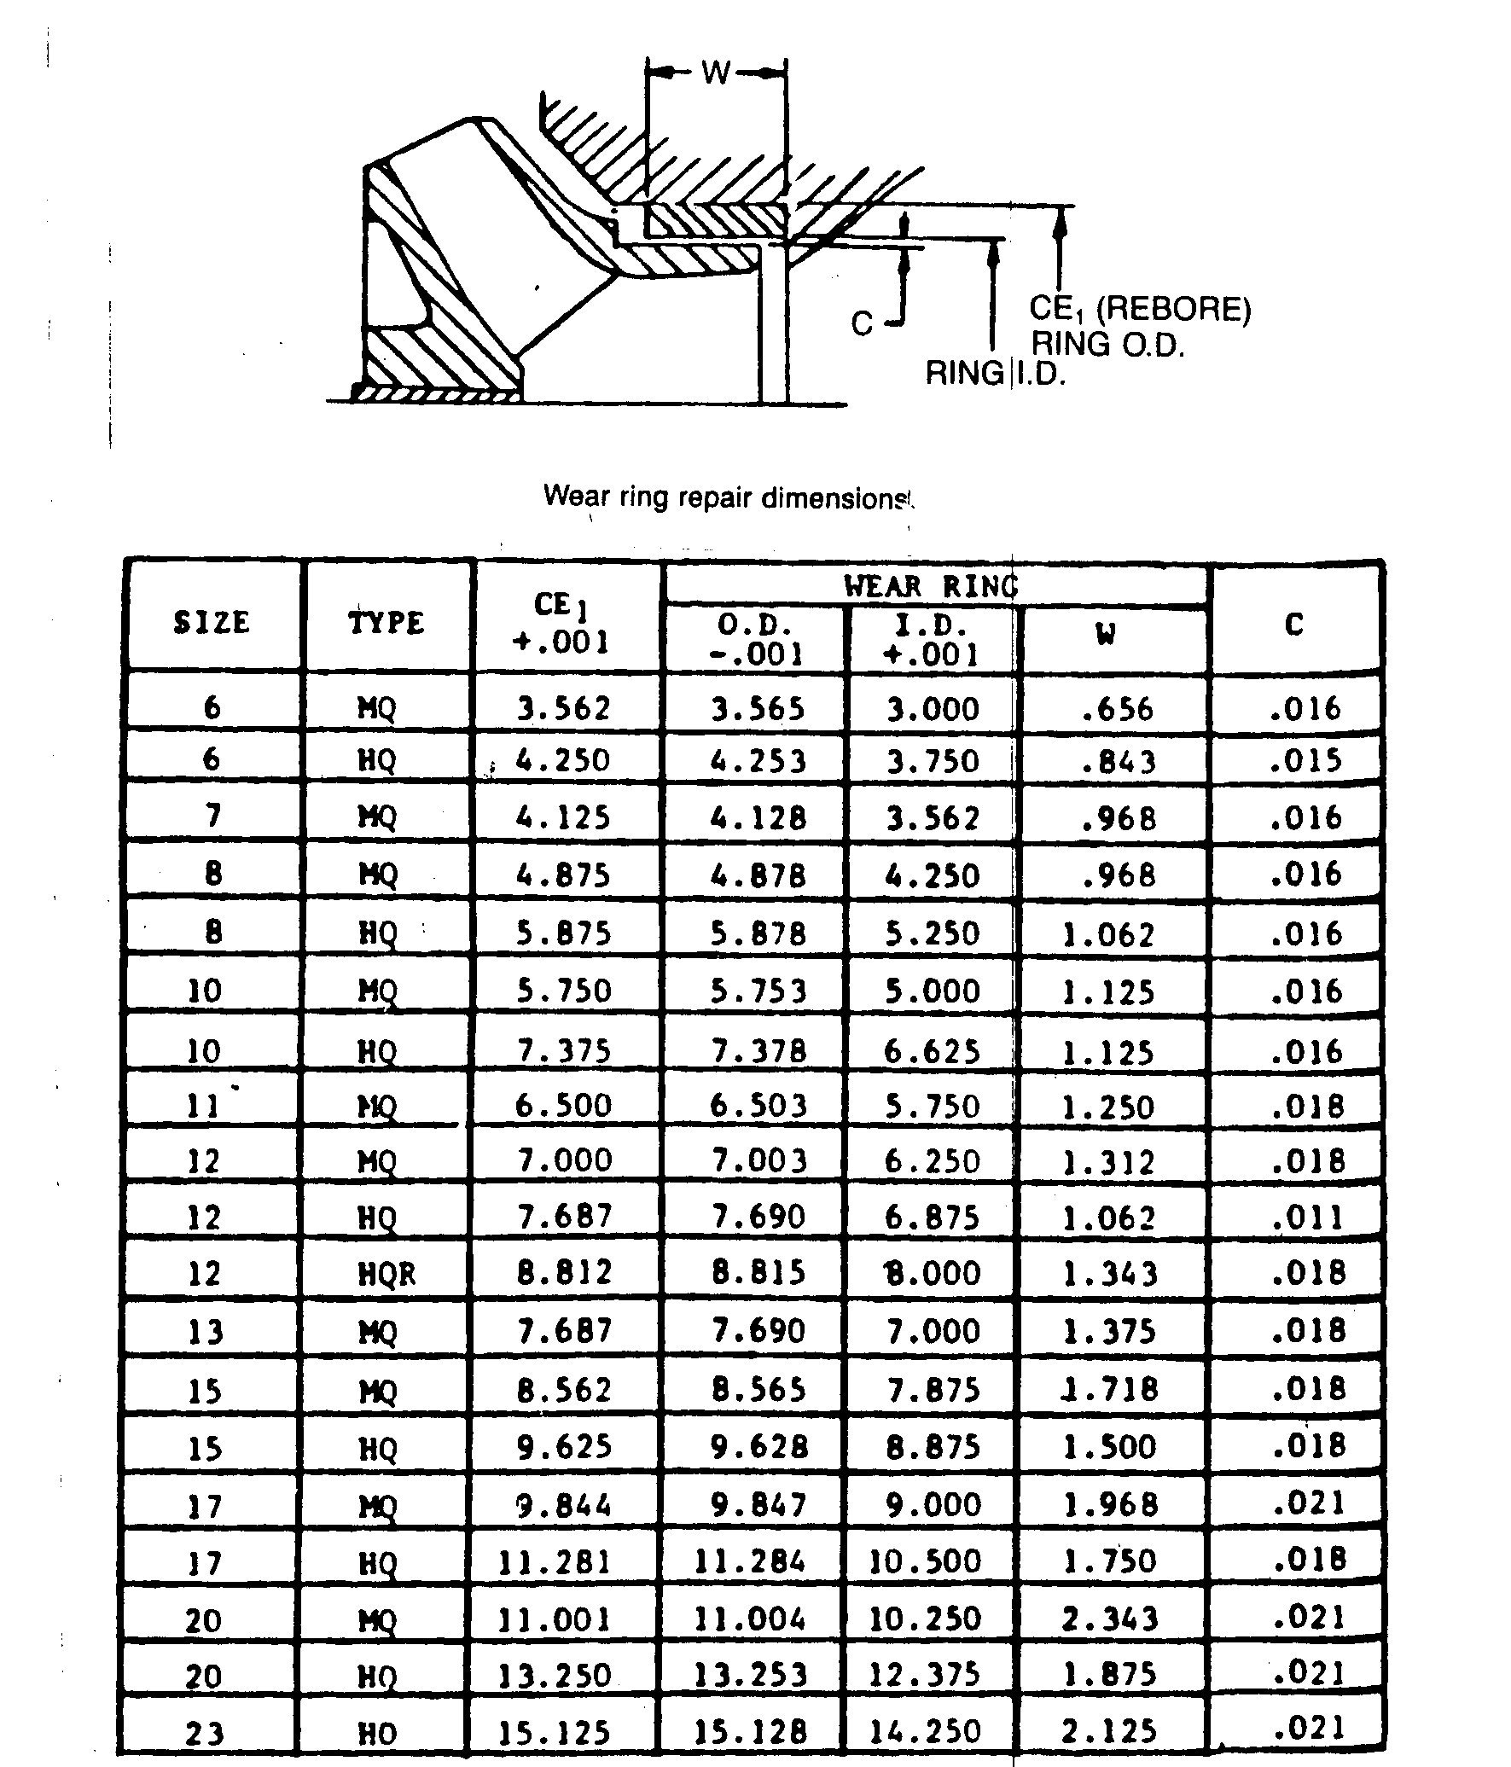

Section-II

2-Impeller Adjustment for vertical turbine pumps

2.1- Driver Types
There are two types of driving motors:

A. Hollow shaft driver:
- Hollow shaft driver where the pump shaft extends through a tube in the center of the rotor and is connected to the driver by a clutch assembly at the top of the driver.
- Hollow shaft driver provides a means to adjust the axial position of the pump rotor for a large distance.

B. Solid shaft driver:

Solid shaft driver where the rotor shaft is solid and project below the driver mounting base. This driver type requires an adjustable coupling for connecting the pump.

2.2-Driver Alignment

Practically all vertical pumps now used in process plants utilize the driver thrust bearing to carry the combined thrust load of the driver and pump. The driver also provides radial alignment for the upper portion of the pump shaft. Reliability of the driver bearings is a prerequisite to the reliability of the pump. Accurate radial and angular alignment between the driver and the pump is therefore essential. Driver shaft runout and concentricity with the mounting fit must be checked prior to assembly or reassembly of the driver on the pump. Referring to the figure on the next page), the following steps are recommended for solid shaft:

1. Thoroughly clean the driver shaft and mounting face.
2.Attach a dial indicator to the shaft and rotate on the driver rabbet fit and mounting face.
- The concentricity of the rabbet fit must be within .002 in. total indicator reading (T.I.R.) per ft of rabbet fit diameter. (2A dial indicator)
- The mounting face must be perpendicular to the shaft within 002 in. T.1.R. per ft of rabbet fit diameter. (2B dial indicator).

3.Mount the dial indicator on the driver housing to check the shaft
runout and end float.
- The shaft runout must not exceed .002 in. (T.I.R.) or 001 in. (T.I.R.) per in. of shaft diameter, whichever is greater.(3A dial indicator).
- The squareness of the split ring groove to the shaft centerline must be
within .002 in. (T.I.R.) (3B dial indicator).
c. Shaft end float must not exceed .010 in. T.I.R., and .005 in. T.I.R. is
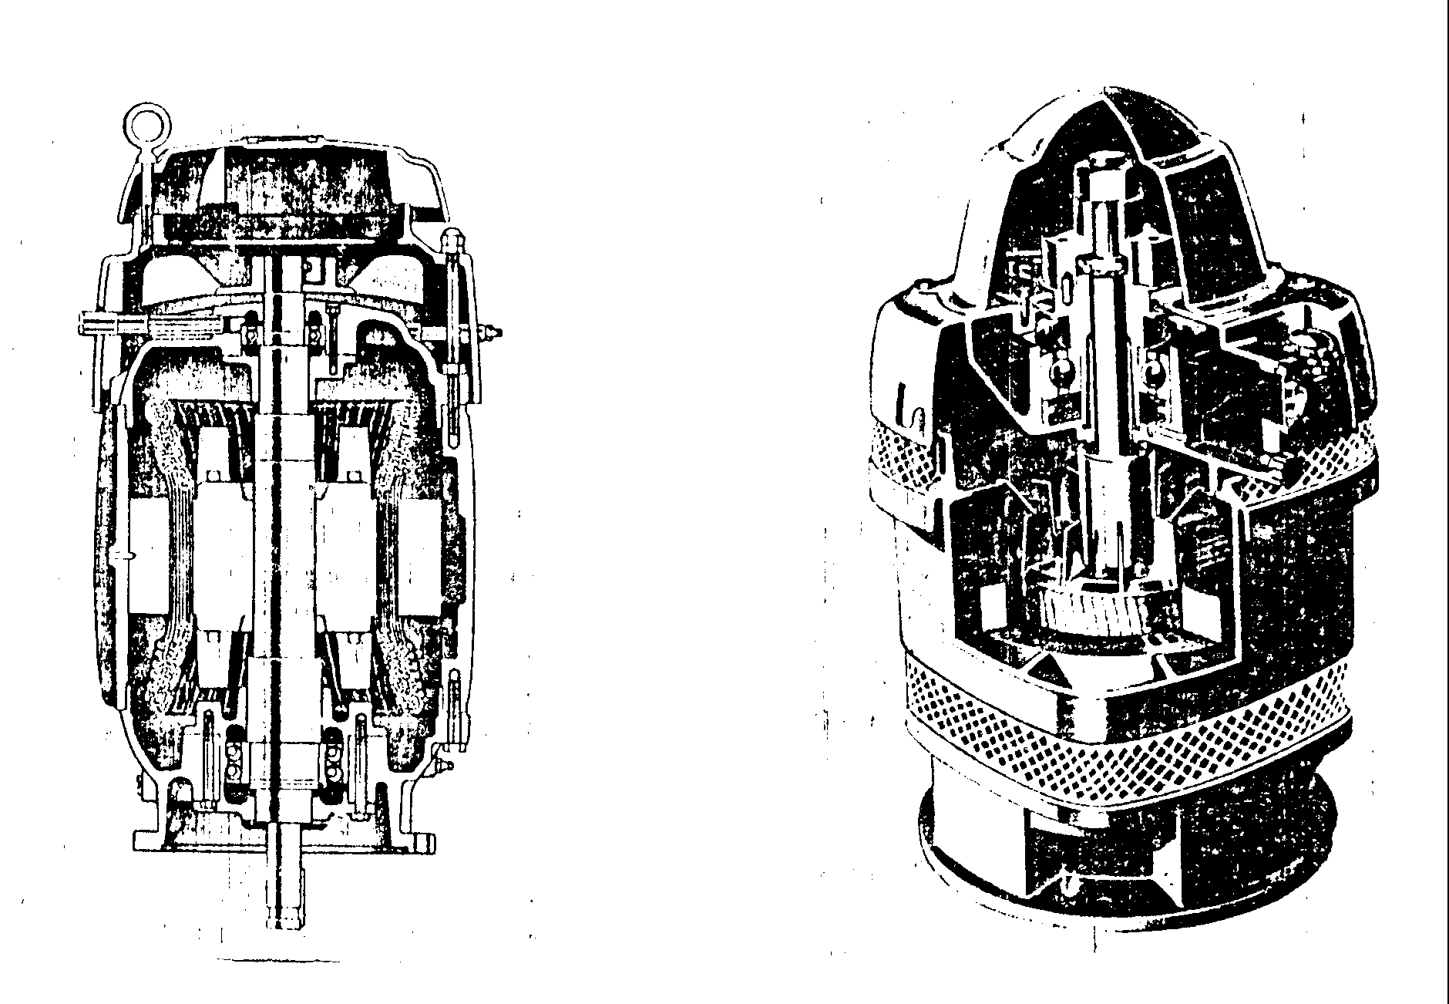
preferred if the pump has a mechanical seal. (3 C dial indicator).

Totally enclosed fan-cooled vertical solid shaft normal thrust motor. | Weather-protected type I (WPI) vertical hollow shaft high thrust motor.

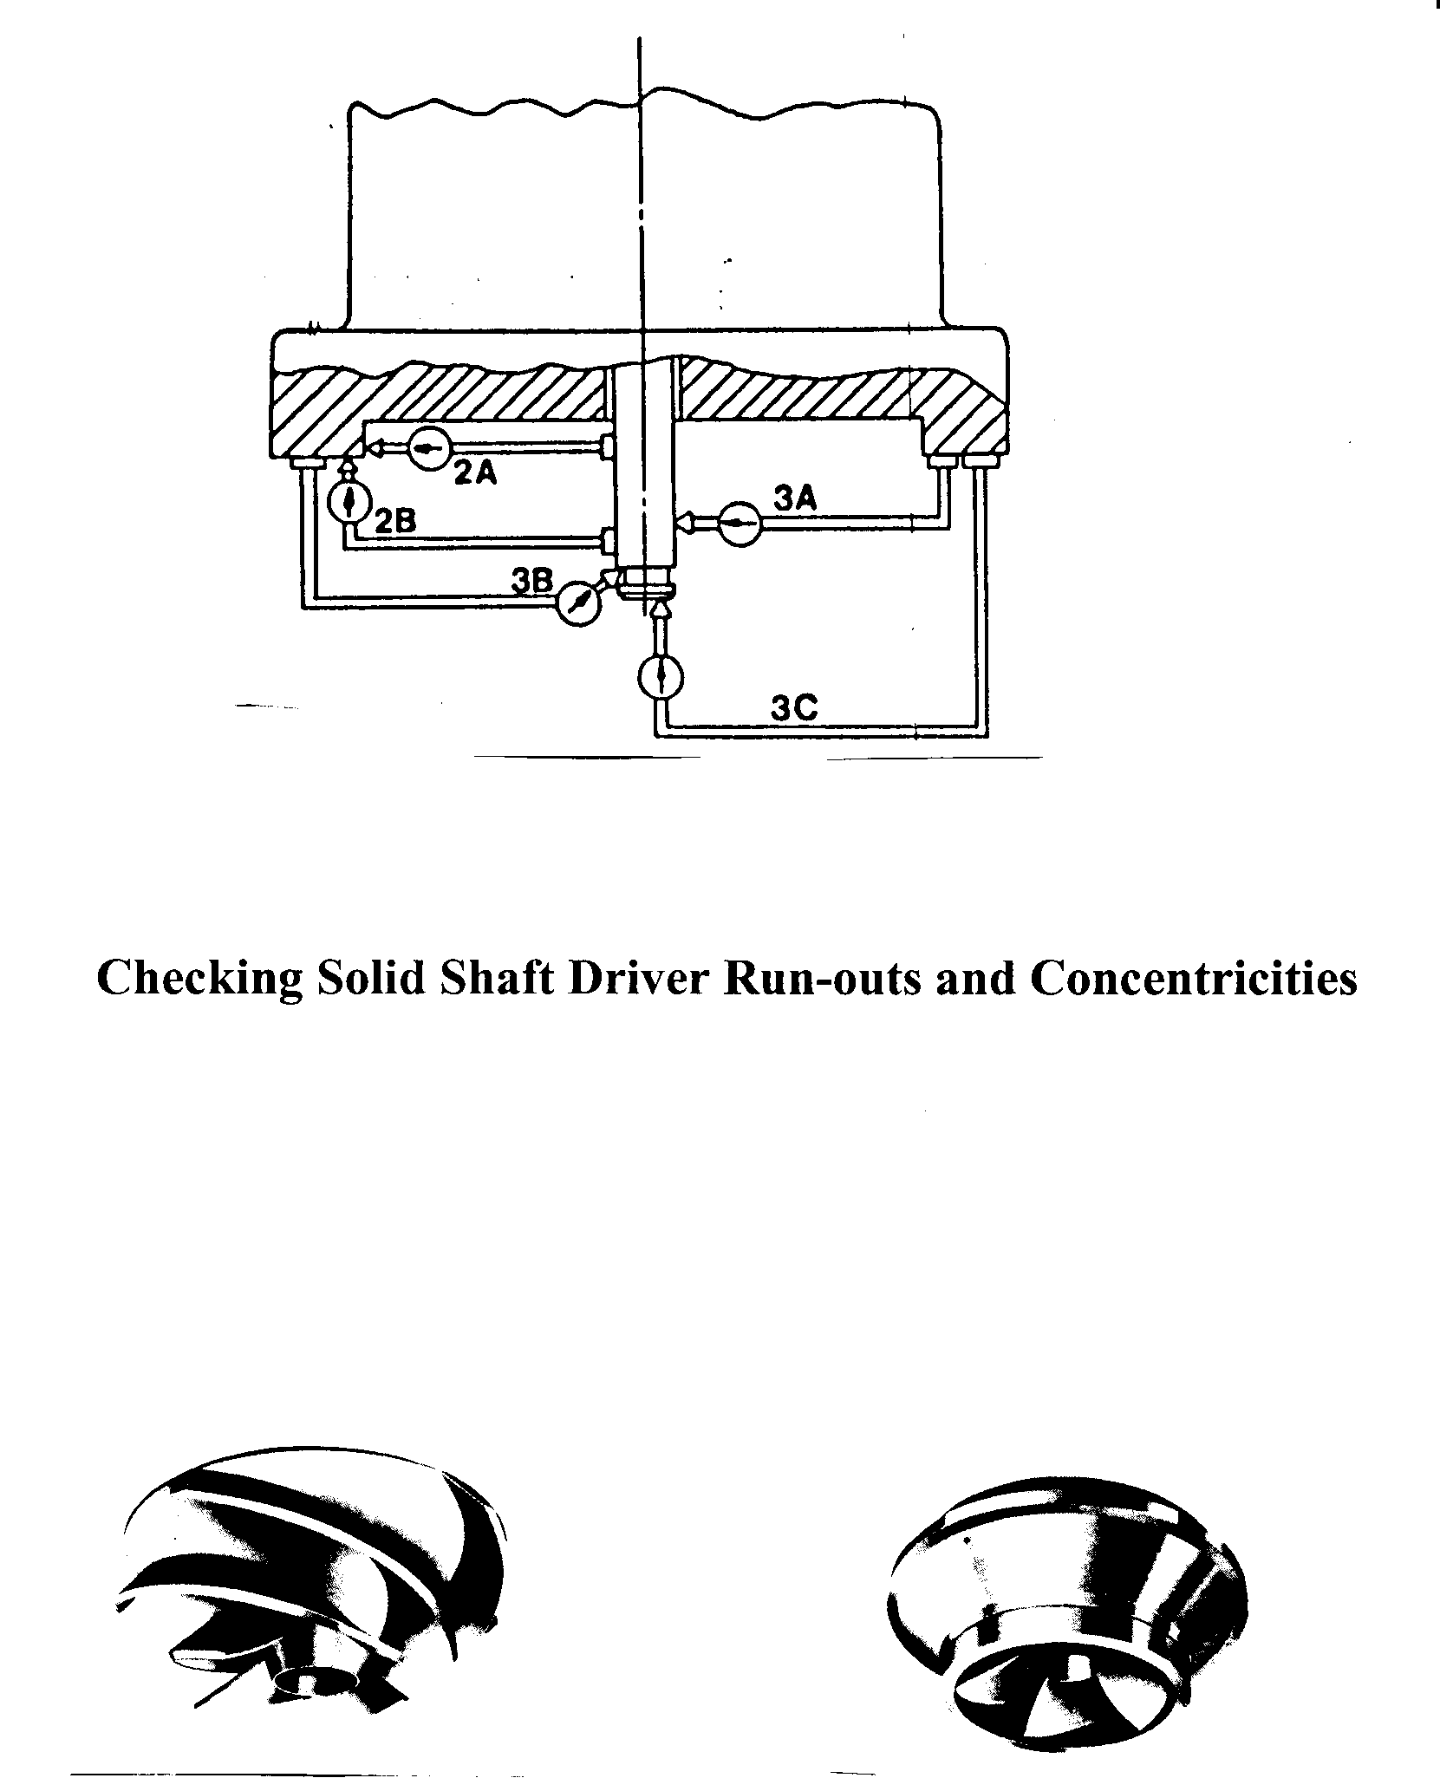

Semi-open Type Impeller Enclosed Type Impeller

Types of Impellers

These requirements are essential for solid shaft drivers, particularly for pumps operating at 3600 rpm or pumps with mechanical seals:

- The driver rabbet fit or the driver mounting flange of the pump is machined to allow clearance for radial movement of the driver.

- If the driver is too large to be moved radially with a soft hammer, four jacking bolts should be installed.

- The driver is then mounted, but the mounting bolts are left loose and the driver is
aligned radially using a dial indicator mounted on the shaft and sweeping the stuffing box bore. This alignment should be within .0005 in. per in. of stuffing box bore for pumps with mechanical seals, and .001 in. per in. of stuffing box bore for packed pumps. If the coupling has an adjusting plate such as the four-piece coupling, it can be unscrewed until it engages the driver half coupling or spacer to verify alignment between the pump shaft and the driver shaft.

- The driver bolts are then tightened and two dowels installed.

- After the coupling is completely assembled, check the runout of the pump shaft or shaft sleeve, measured by a dial indicator immediately above the stuffing box or mechanical seal. This runout should not exceed .002 in. T.I.R. for new pumps operating above 1400 rpm, or 004 in. T.I.R. for new pumps operating below 1,400 rpm.

2.3-Impeller Adjustment-General

Proper impeller adjustment positions the impeller inside the bowl assembly for maximum performance. The impellers must be raised slightly to prevent dragging on the bowls. Impellers are of two basic types “enclosed” and “semi-open” (sometimes called “semi-closed”), the type impeller will determine proper adjustment. The type of impellers Installed in the pump can be determined from the pump nameplate or packing slip.

2.3.1.ENCLOSED IMPELLERS - Enclosed impellers should be raised 1 1/2 to 2 turns of the adjusting nut or approximately 1/8”.

2.3.2.SEMI-OPEN IMPELLERS - The adjustment of semi-open impellers is more critical than for enclosed Impellers. The performance of the pump will vary considerable for a small change in the impeller setting. For maximum performance the impeller must run within a few thousands' of the bowl seat the exact shaft adjustment will vary according to variables of each installation; however,

for close coupled units a general rule of .015" plus .005” for each 100 feet of discharge head produced by the pump plus .005” for each 10feet of column assembly will provide near ideal adjustment. The highest discharge head the unit will be expected to operate against should be used for this adjustment. As an example-a pump designed to operate at 400' discharge head but will also be operated against a closed valve for short periods at which time it will produce 500’, therefore 5 x .005” = .025". If the unit has 20’ of column assembly - 2 x .005 = .010". The initial adjustment would be .025”, + .010” + .015”, = .050".

CAUTION: The impellers must be down against the bowl seat when starting impeller adjustment - all dimensions and instructions given above assume the impellers are initially all the way down. When pumps are subjected to suction pressure the pressure acting against the shaft tends to raise it. If the suction pressure is great enough it can raise the shaft. Make sure the shaft is down when starting to adjust the impellers.

If, after making the above adjustment the pump does not deliver its rated capacity the impellers can be lowered one step at a time until the lowest possible adjustment is achieved without the impellers dragging. On the other hand, if the impellers appear to be dragging after the initial adjustment the unit should be stopped and the Impellers raised one step. Dragging impellers will increase the load markedly and can usually be heard and felt as increased vibration.

2.4.SEMI-OPEN IMPELLER RE-ADJUSTMENT CHART

Ordinarily Impellers will not require re-adjustment if properly set at initial installation Almost no change in performance can be obtained by minor adjustment of enclosed impellers; however, the positioning of semi-open impellers has a definite effect on the performance of 'the pump. This fact is sometimes used to adjust the output of the pump without valving. The figure illustrates the general effect of raising semi-open impellers.

After extended operation under abrasive conditions the sealing faces between semi-open impellers and the bowl will wear causing a reduction in performance. The pump performance can be brought back up to almost "as new" by proper re-adjustment of the impellers.

NOTE: All adjustments of the impellers will change the mechanical seal setting. Unless the adjustment is to be very minor it is recommended that the seal be loosened from the shaft until the adjustment is complete and then re-set.

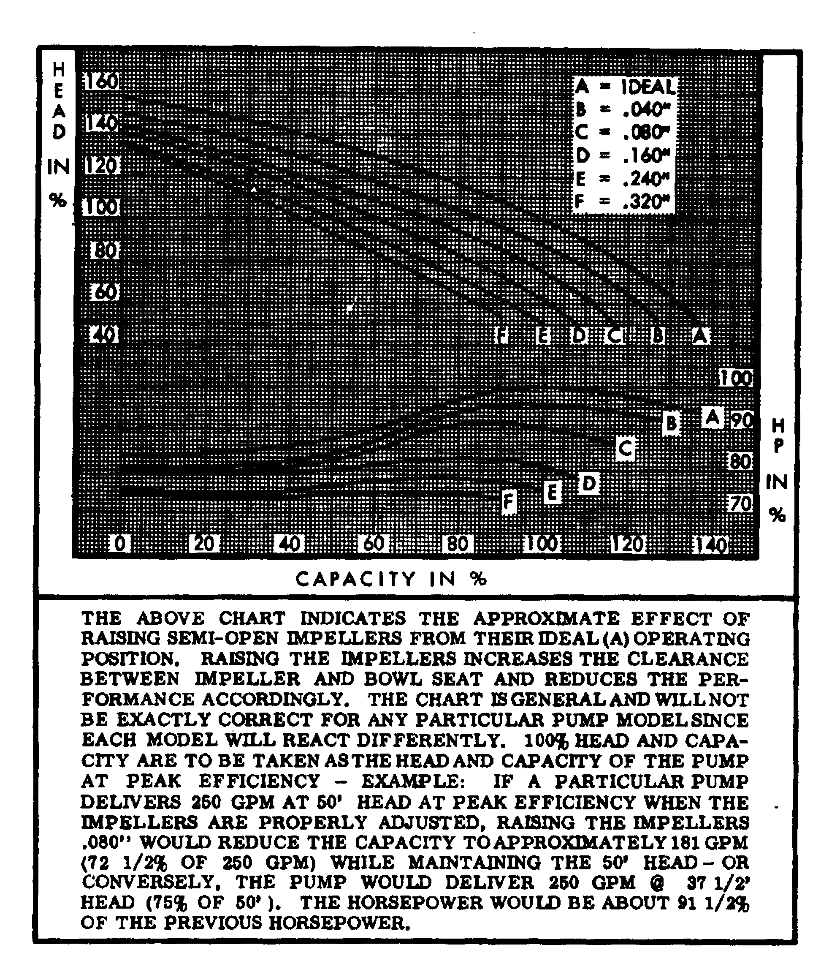

Effect of Rising Semi-open Impellers
2.5. Impeller Adjustment

2.5.1 Hollow Shaft Driver

Impeller adjustment when using hollow shaft drivers is accomplished at the top of the driver by the following procedure. The driver canopy (cover) will have to be removed before beginning.

- Install headshaft.
- Install driver clutch in accordance with driver instruction manual and bolt into place.
- Install gib key, making sure top of gib key pushes down below top of clutch.
- Check shaft position - raise shaft slightly by hand and lower until there is a definite feel of metal contacting metal. This indicates the impellers are "on bottom" and is the correct starting position for impeller adjustment.
- Thread headshaft nut down (RIGHT HAND threads) until impellers are just lifted off their seat and the shaft will rotate freely. When semi-open impellers are used the correct determination of the point where the impellers just barely clear their seat is very important for proper adjustment.
- Adjust impellers as outlined in 2.3.2.
- Lock headshaft nut with lockscrews inserted down through holes in headshaft nut and threaded into driver clutch.

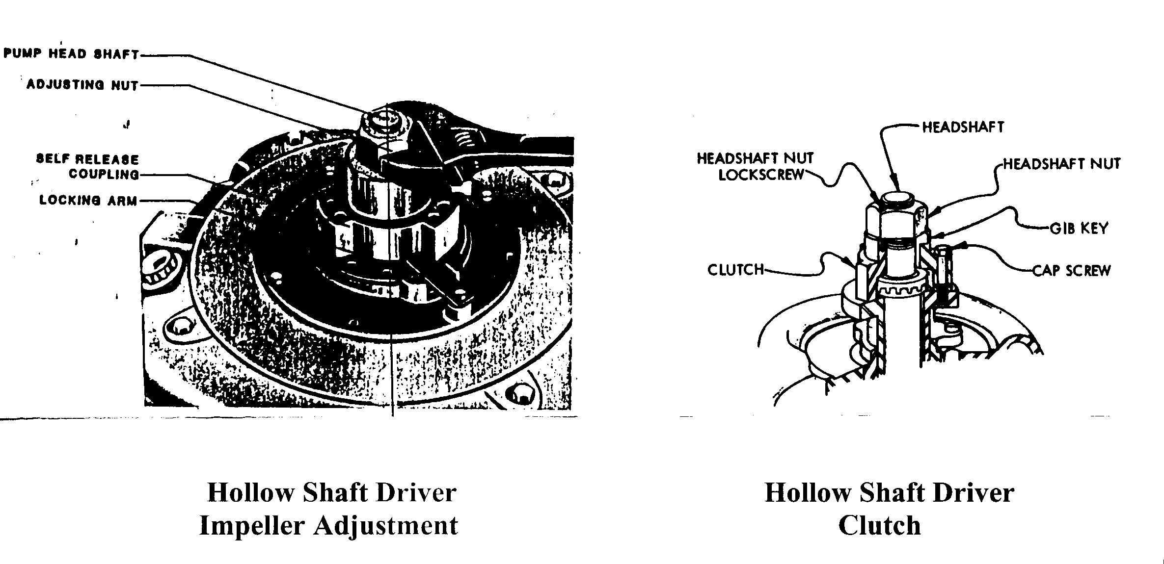
CAUTION: Always lock headshaft nut before starting driver. Failure to do so could result in damage to the pump and driver.

2.5.2 Hollow Shaft Driver Reserve Protection Clutch

If the driver is accidentally run with reverse rotation, the deepwell pump shaft couplings may unscrew and cause damage. A reverse protection clutch automatically disengages the pump shaft from the driver if this occurs.

2.5.3 Hollow Shaft driver Nonreverse Ratchet

If the foot valve or check valve fails in a deepwell pump installation, when the driver is de-energized the water will turn back down the discharge column, and the pump will act as an unloaded turbine and achieve a reverse rotation that can reach rather high speed, it seldom causes damage unless water-lubricated column bearings are run dry, or an attempt is made to restart the driver while the pump is running backward. Hollow shaft drivers are often provided with nonreverse ratchets so hat reverse rotation does not occur. Alternatively, some systems have time-delays to prevent premature restart.

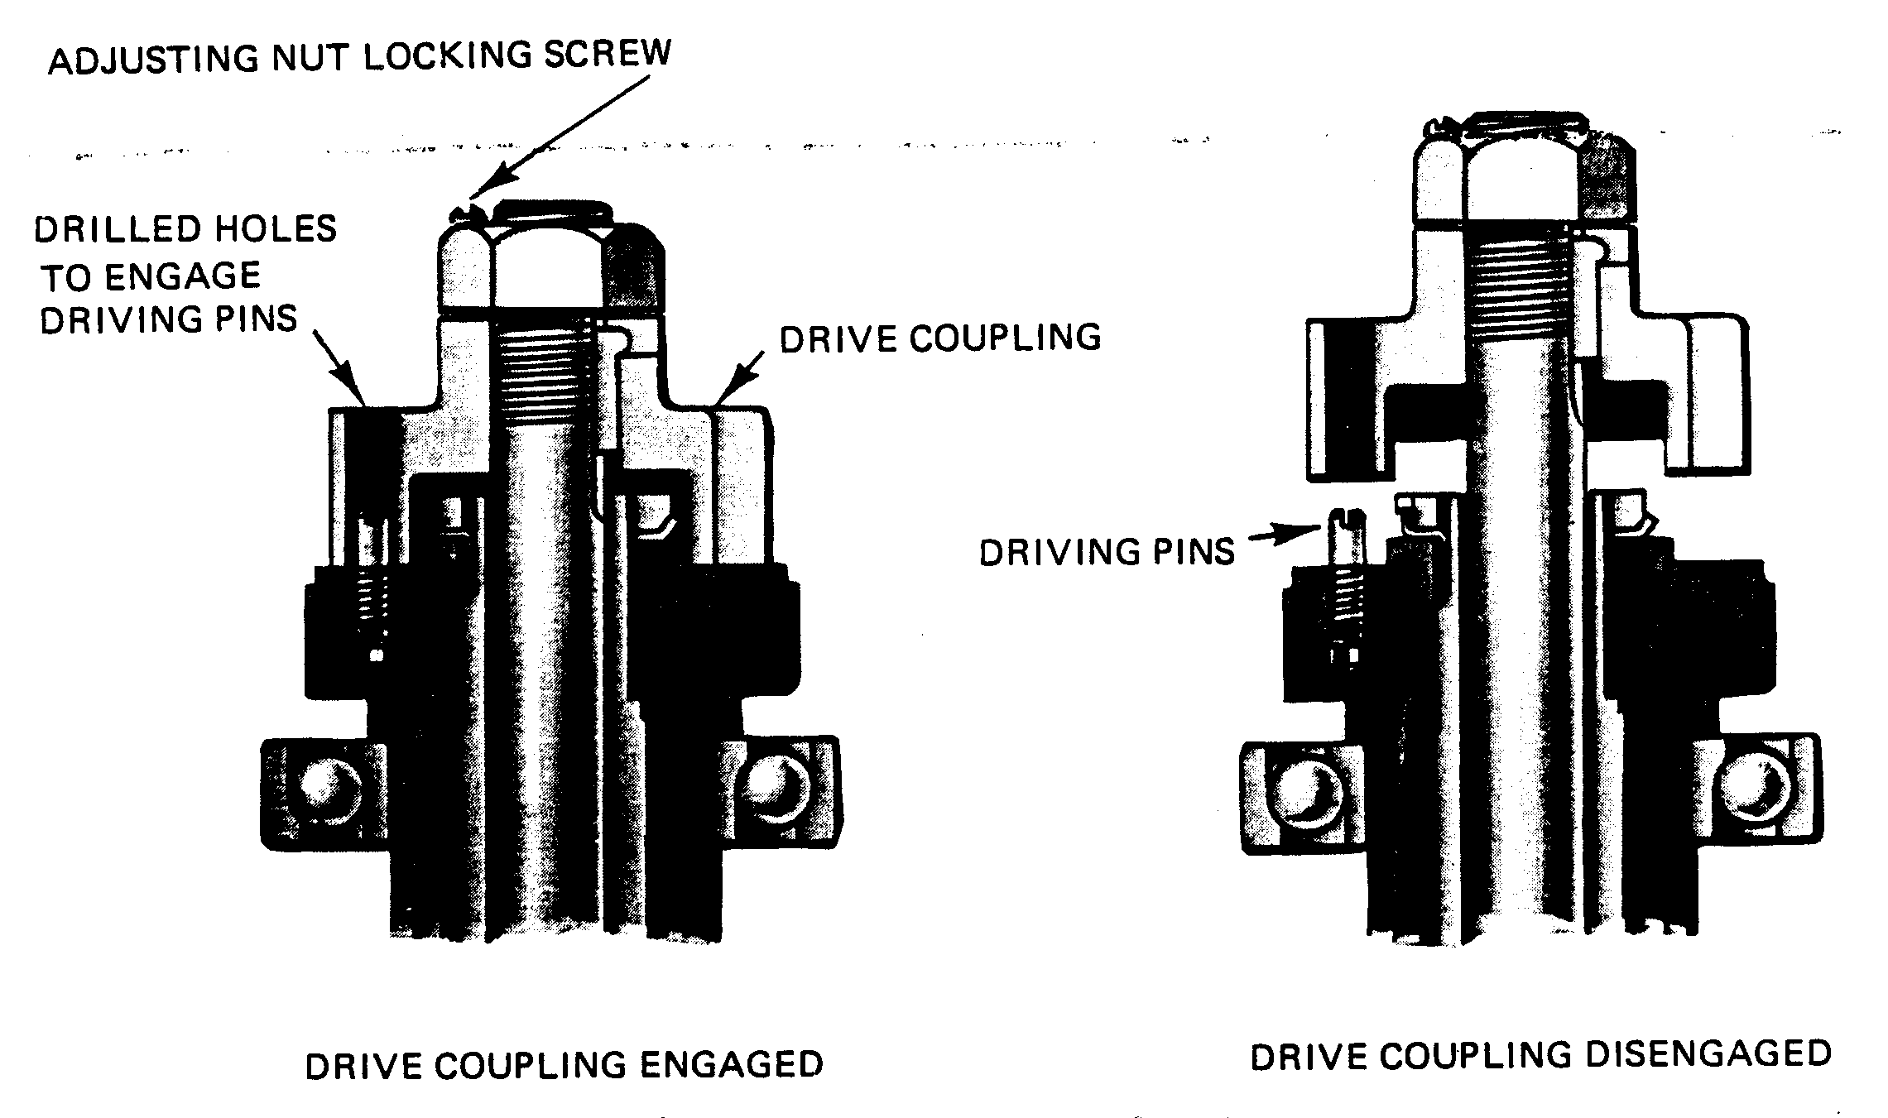
Impeller Adjustment

2.6. Solid Shaft Driver

Impeller adjustment when using solid shaft drivers is accomplished in the adjustable flanged coupling located below the driver.

Adjusting The Adjustable Flanged Couplings

- Assemble coupling on pump and driver.
- Back adjusting nut up shaft (threads are RIGHT HAND) until the nut bears firmly against spacer or driver shaft and headshaft will not move down. This will insure that the impellers are all the way down against their seat and in proper position for adjustment.
- Thread adjusting nut down until impellers are just lifted off their seat and the shaft will rotate freely. When semi-open impellers are used the correct determination of the point where the impellers just barely clear their seat is very important for proper adjustment.2.3.2.
- Lock adjusting nut by installing lockscrew thru threaded hole in side of pump half coupling and into hole drilled in side of adjusting nut. Adjusting nut may have to be turned slightly to line up hole; however, note that there are two tapped holes in side of pump half-coupling which will minimize the amount the adjusting nut will have to be rotated.

CAUTION: Always lock adjusting nut before starting driver. Failure to do so could result in damage to the pump and driver
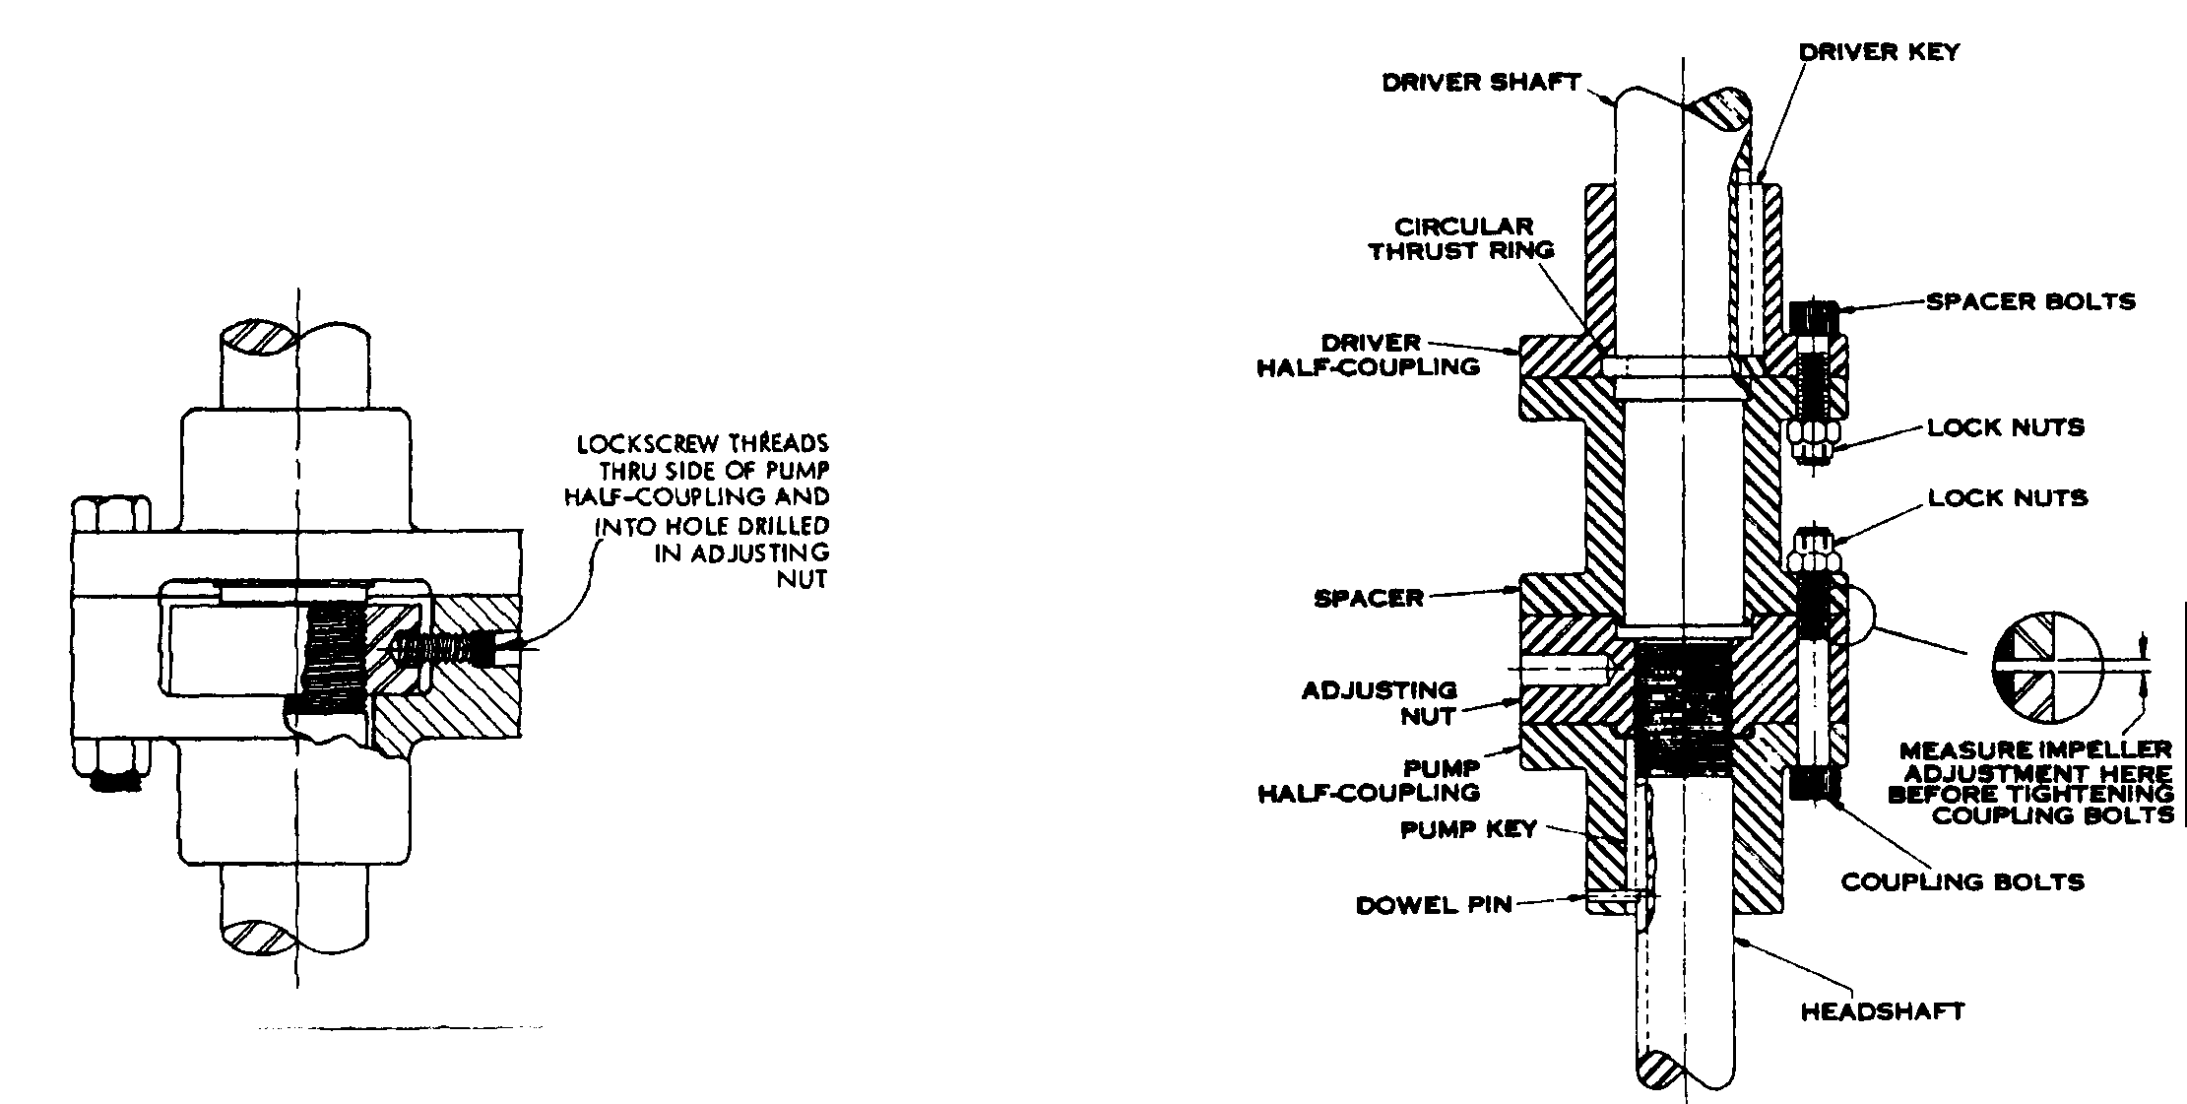

Coupling without Spacer Coupling with Spacer

Section-III

3-Vertical Turbine Pump Maintenance

Johnston Pump Company

Assemblies Description and Installation
General-A Johnston vertical turbine pump is composed of three main subassemblies:

- Bowl assembly
- Column n assembly
- Discharge head assembly

In a product-lubricated pump, all bearings in these main subassemblies are lubricated by the fluid being pumped. The following description of the subassemblies is that of a vertical turbine pump with standard components.

Safety Precations-Personnel must be protected at all times from rotating shafts and couplings. All screens and protective devices furnished with the pump, driver, and related equipment must be installed prior to pump startup and must remain in place during operation. If protective devices are not furnished, then the user must provide safety equipment conforming to regulations, codes, and statutes applicable to the operation site.

3.1 Bowl Assesibly

The bowl assembly is composed of the suction case, discharge case, intermediate bowls, impellers, lock collets, bearings, and a bowlshaft with a coupling.

  - The discharge case, suction case, and bowls are close-grained cast iron. The dual bowl bearings are high-lead bronze and rubber. The suction case bearing is an extra-long, high-lead bronze bearing packed with waterproof grease.
  - Two different impeller designs are available: closed or semi-open Impellers can be furnished in bronze, cast iron. C1osed cast-iron impellers are coated with vitreous enamel. Each closed impeller is equipped with a replaceable aluminum-bronze seal ring shrink-fitted to the impeller skirt. Impellers are locked onto the bowlshaft with tapered steel lock collets or with thrust rings (optional).

3.2 Column Assembly-The column assembly is composed of the column pipe with coupling, bearing retainer with bearing, and lineshaft with coupling.
2.1 The column pipe is high-quality standard steel pipe machined for
straight thread, butt-joint construction.
2.2 The lineshaft is stainless steel of precision pumpshaft quality.
2.3 The bearing retainer is cast bronze machined for a butt-fit between
the column. pipe ends. The rubber bearing is a snap-in type.

3.3 Discharge Head Assembly-The discharge head assembly includes the discharge head, packing box assembly, top column flange assembly, and headshaft assembly.

3.1 The packing box assembly consists of a cast-iron packing box with a high-lead bronze bearing; a bronze lantern ring; a split-type bronze packing gland with studs, nuts, and clips; and six rings of formed packing.

3.2 The headshaft assembly includes a one-piece stainless steel headshaft, an adjusting nut, lock screws, and a gib key.

3.4. Installation and Maintenance

1- Bowl Assembly
Verify the bowl shaft projection during assembly, i.e. the distance from the column seat to the top of the bowel shaft when the impellers are seated against the suction case.

Note: This dimension must be verified after each section if the column is added to the pump.

2-Column assembly-Clean all threads. Start all threads by hand.
2.1- Attach the bottom column section to the bowl assembly. Couple the
lineshaft to the bowlshaft; shaft threads are left-hand.
2.2- Using pipe wrenches, butt the shaft ends tightly together, but take care not
to distort them. Caution: Do not use pipe wrenches on the shafting at the
bearing journal. Support the lineshaft to keep it from bending.
2.3- Verify that the shaft is centered in the column. If it is not centered, the
shaft may have been bent and must be removed and replaced. If the shaft
is properly centered, proceed to the next step.
2.4- Install a bearing retainer assembly inside the column coupling.
2.5- Measure the projection of the shaft above the bearing retainer surface
where the next section of column will butt. Compare this measurement
with the bowlshaft projection. The measurement should be within 1/8-inch.

3-Hollw-shaft : electric motor, gear, or belt-drive-Re move the driver cover and the top drive coupling.
3.1- Try the fit of the coupling by slipping it over the headshaft. It must be a
sliding fit.
3.2- Remove the coupling and try the gib key in the headshaft keyway and the
coupling keyway. This must also be a sliding fit, but not loose.
3.3- Raise the driver and check the mounting register for burrs and nicks. Also
check the discharge head register. Smooth these registers with a mill file.
3.4- Lower the driver over the headshaft and bolt it to the discharge head. Take
care not to damage the threads or bend the headshaft.

4- Pump alignment-Make sure the pump is aligned. If it requires alignment, do not plumb the discharge head and drive. Instead, adjust the discharge head ring base or flange with steel wedges or shims so that the headshaft is centered in the drive hollow shaft Place the wedges or shims beneath the discharge head or subbase (if used).

5- Impeller adjustment-The impellers must be adjusted so that they will turn without rubbing on the top or bottom while the pump, is operating. Make this adjustment as follows:

5.1- Raise the impellers until they turn freely by turning the adjusting nut
three-quarters of a turn for each 100 feet of total pump head.
5.2- However, it may be necessary to modify this adjustment as detailed in
section 2.
3.5.Vertical Turbine Pump Repairs

(Assembly and Disassembly)
Vertical turbine pump bowl assembly, product lubricated, lock collet construction, closed impellers.

- Assembly Procedure:
- Install the bearing in the bowls where dual bearing are used. Press the bronze bearing into place, then install the rubber bearing, using rubber adhesive, to hold them in place.
- Position the bottom impeller at the pipeline etched on the bowl shaft. Clamp the bowl shaft in a vice with soft metal cover on the jaws. Slip on an impeller and taper lock collet over the end of the bowl shaft and lock it into position using a lock collect hammer.
Note: When the lock collet is in the proper position, it will project about 1/8 inch
above the impeller hub.
- Use a straight edge to verify that the bottom of the impeller wear ring is aligned with the pin line on the bowl shaft. Install sand collar on the shaft beneath the impeller.
- Insert the bowl shaft into suction bearing, positioning it so that the impeller seats in the bowl wear ring seat. Remove the pipe plug from the bottom of the suction piece.
- Thread the stop into the bottom of the shaft and tighten it firmly to seat the impeller in the bowl. Keep this stop tight while assembling the bowl.
Note: After that the bowl assembly is completed, the stop must be removed.
- Slip an intermediate bowl over the end of the shaft and bolt or thread the bowl in position.
- Place the next impeller and lock collet on the bowl shaft and use the lock collet hammer to lock them in position in the bowl ring seat.
- Now, check the bowl shaft endplay by removing the stop and measure the lateral travel of the shaft. The travel is the endplay. Re-lock the shaft again using the stop.
- Following the above steps, install the bowels and impellers for the remaining stages. After that the final impeller is positioned, install the top inter-bowl and the discharge case. Thread the assembly in position. Re-check the endplay again.
10- Check the bowl shaft projection, while the impellers are in their lowest
Position.
- Remove the stop in the bottom of the shaft.
Make sure that the rotating elements turn freely by hand. If
They do, the bowl assembly is now ready to install.
B- disassembly Procedure-To disassemble the bowl assembly, simply reverse the assembly procedure described above. Be sure to raise the shaft to its highest position before attempting to drive off the impeller(s). Use the recessed end of the lock collet hammer to remove the impeller(s).
Product-lubrication Pump
Typical Turbine Pump Bowl Assembly-with Semi-open Impeller and Suction Case
(2 Stages Shown)
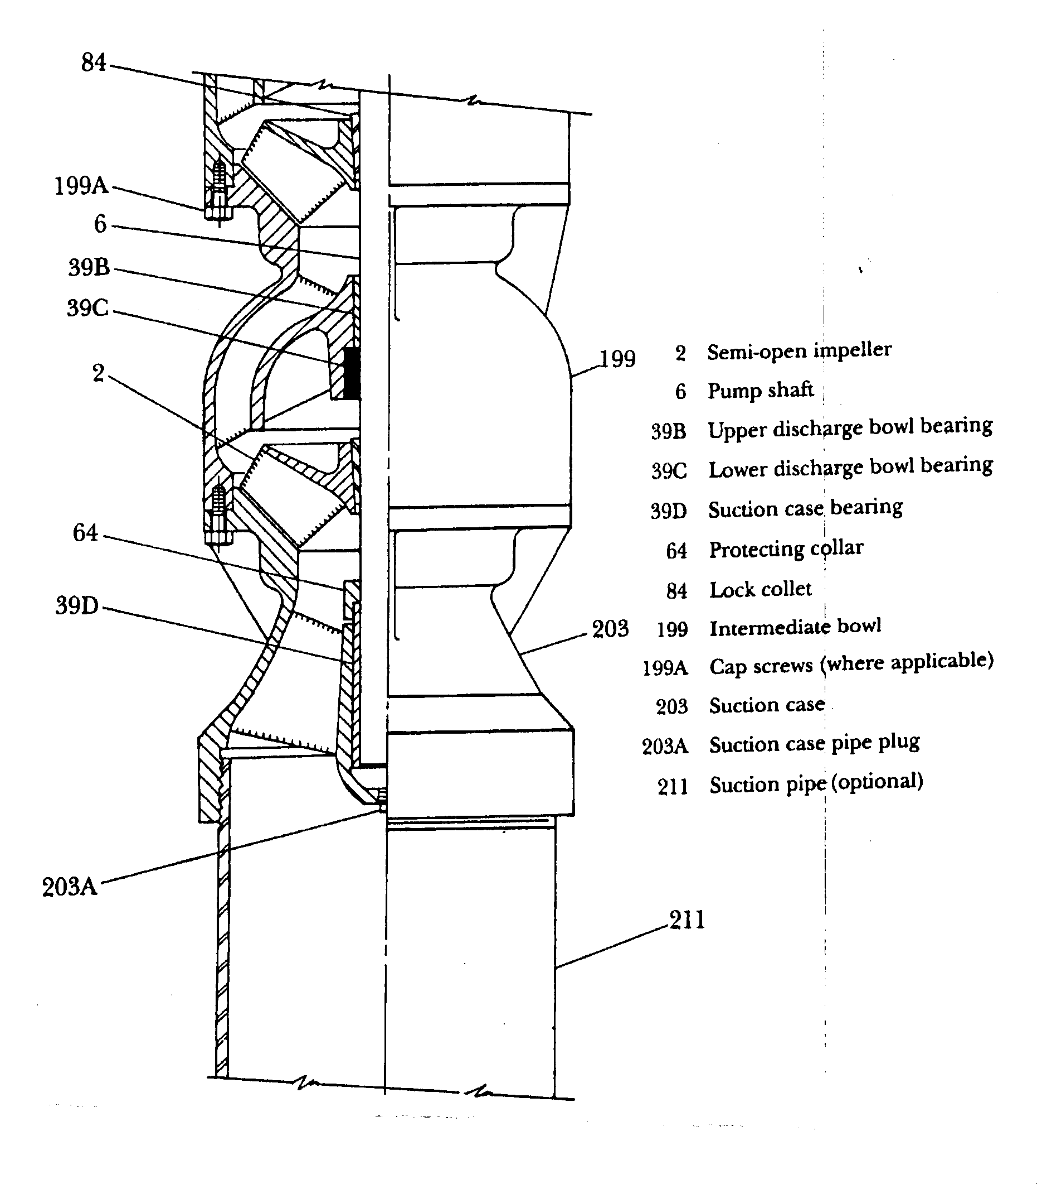

3.6.Impeller Assembly Methods:

- Lock collet construction (split taper sleeve).
- Thrust ring construction.

The Thrust Ring Construction:
A thrust ring may be installed either at the top or bottom of an impeller; before you commence work on your pump, it will be necessary for you to determine where the thrust ring is located. If the thrust ring is located on the bottom of the impeller, you should start working from the discharge end of the bowl assembly. However, if the thrust ring is located on the top of the impeller, you should commence from the suction end of the bowl assembly.
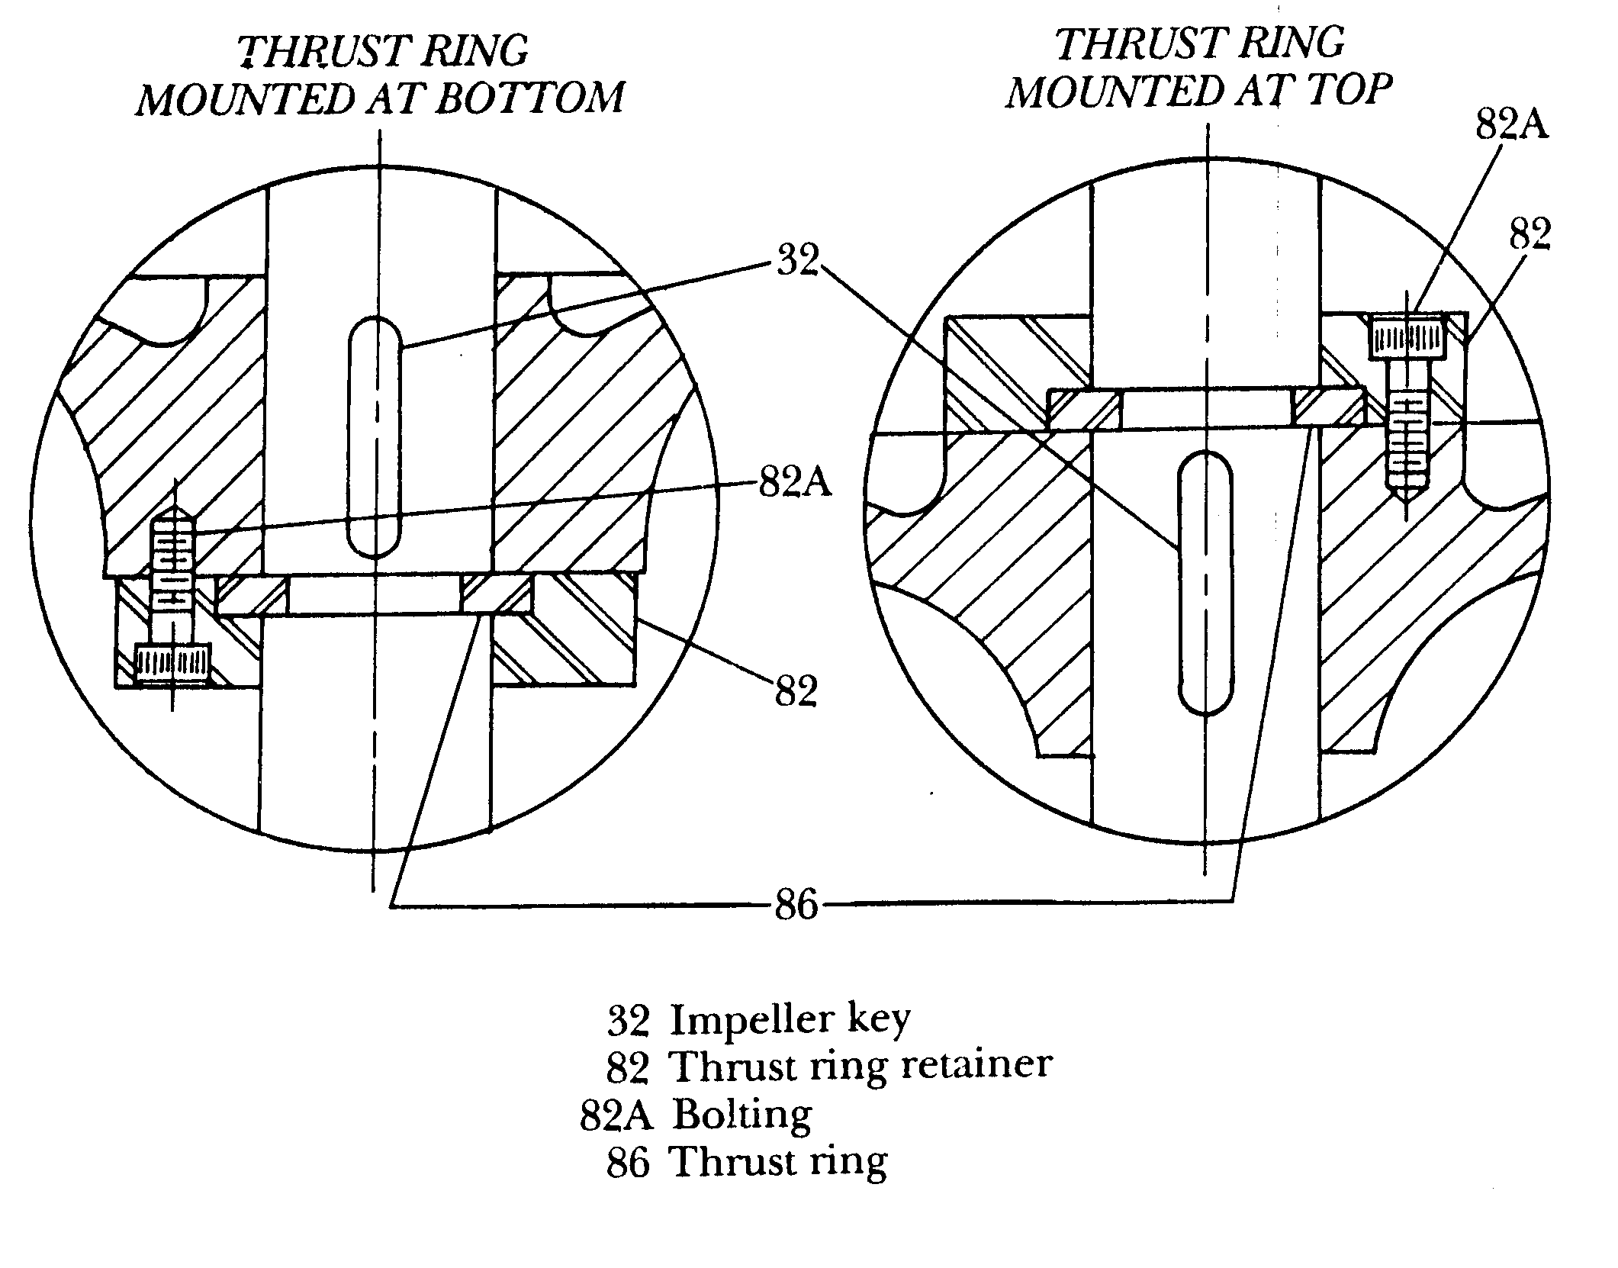

3.7. Troubleshooting

Vertical Turbine Pump

Troubleshooting

Condition | Probable Cause | Remedy
Pump will not run | 1.Motor overload protection contacts open.  2.Blow fuse, broken or loose electric connections.  3.Faulty control equipment.  4.Pump binding. | 1.Check wiring diagram  2.Check fuses, relays.  3.Check all circuits and repair.  4.Pull master switch, rotate pump by hand to check. Check impeller adjustment or disassemble unit to determine cause.
Pump runs but no water delivered | 1.Line check valve backward.  2.Line check valve stuck.  3.Unit running backwards.  4.Lift too high for pump.  5.Pump not submerged.  6.Excessive amounts of air or gas.  7.Intake strainer or impeller plugged, or pump in mud or sand.  8.Impeller(s) loose on shaft. | 1.Reverse check valve.  2.Free the valve.  3.Check direction of rotation.  4.Check with performance curve.  5.Lower pump if possible or add fluid to system.  6.Correct conditions.  7.Start & stop pump several times or use line pressure if available to back flush. Pull pump and clean.  8.Pull unit and repair.
Reduced Capacity | 1.Bypass open.  2.Lift too high for pump.  3.Motor not coming up to speed.  4.Strainer or impellers partly plugged.  5.Scaled or corroded discharge pipe or leaks anywhere in system.  6.Excessive amounts of air or gas.  7.Excess wear due to abrasives.  8.Impellers not properly adjusted.  9.Impeller(s) loose on shaft. | 1.Check by pass valving.  2.Check performance curve.  3.Check voltage while unit is running.  4.Start & stop pump several times or use line pressure if available to back flush. Pull pump and clean.  5.Replace pipe or repair leaks.  6.Correct conditions.  7.Replace worn parts.  8.Adjust impellers.  9.Pull unit and repair.
Motor Overloaded | 1.Specific gravity higher than design.  2.Operation at point on pump curve other than design.  3.Motor speed too high.  4.Impellers dragging.  5.Pump in bind. | 1.Correct specific gravity or re-evaluate system.  2.Check performance curve.  3.Line voltage too high or incorrect frequency.  4.Re-adjust.  5.Pull master switch, Rotate pump[ by hand to check. Dis-assemble unit to determine cause.
Pump Vibrating Excessively and Noisy | 1.Unit running backwards.  2.Pump breaking suction and pumping air.  3.Loose fasteners.  4.Badly worn motor or pump bearings.  5.Impeller(s) loose on shaft.  6.Pump & Motor shafts misaligned.  7.Stress due to piping misalignment. | 1.Check direction of rotation  2.Lower pump or reduce capacity.  3.Check all bolts, nuts, etc.  4.Pull unit and repair.  5.Pull unit and repair.  6. Pull unit and repair.  7.Correct.
Excess Wear | 1.Abrasivers.  2.Pump in bind.  3.Vibration. | 1.Clean system.  2. Pull master switch, rotate pump by hand to check. Dis-assemble unit to determine cause.  3.Determine cause and correct.
Corrosion | 1.Impurities.  2.Corrosive liquid. | 1.Analyse fluid.  2.Change to Corrosion Resistant materials.

Troubleshooting Chart

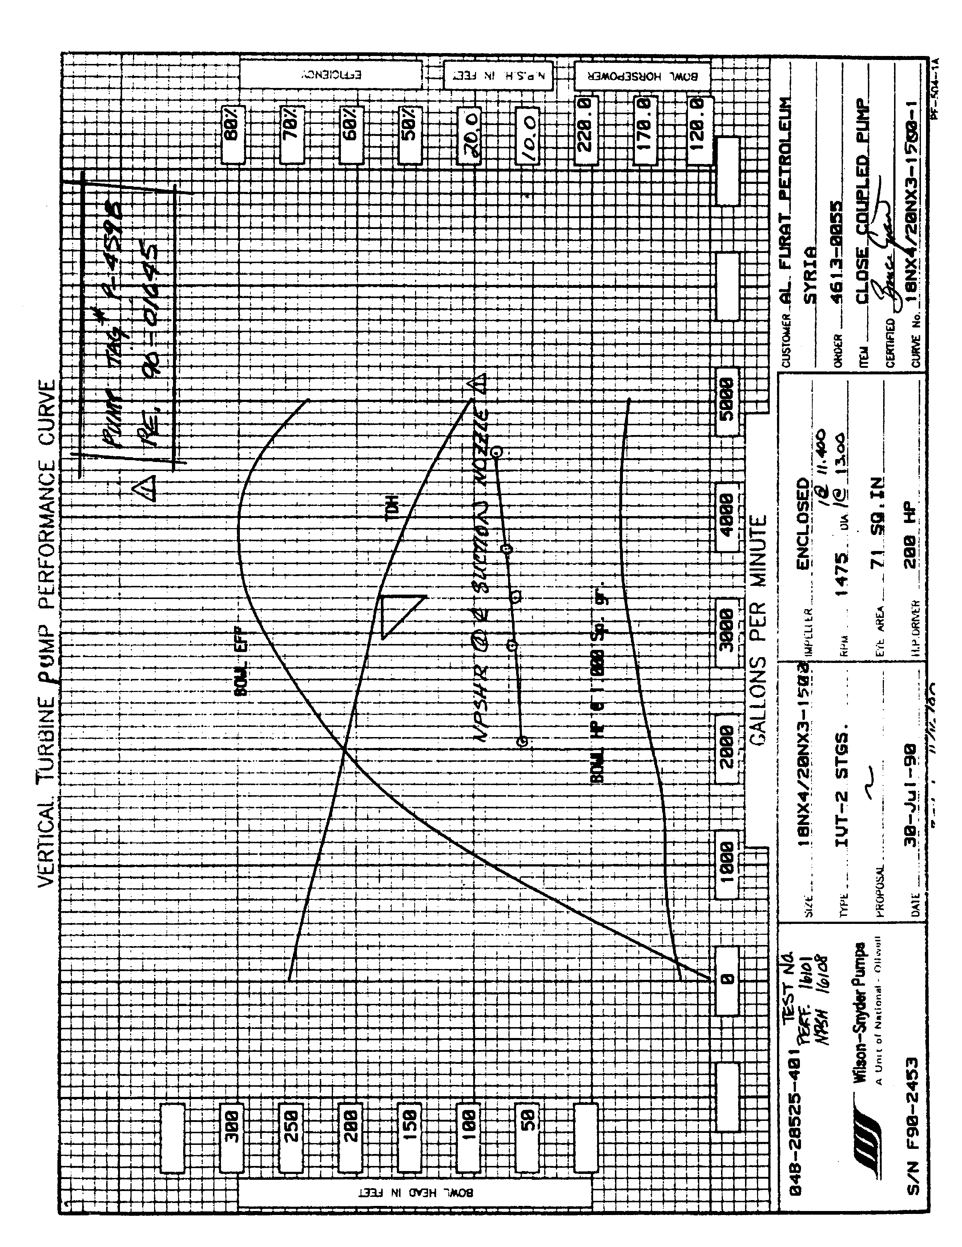

3.8.Vertical Wet-Pit Cantilever Type Volute Pump

The figure illustrates what is called a cantilever-shaft pump, which has the unique feature of having no bearings below the liquid surface. The shaft is exposed to the liquid pumped, External antifriction grease-lubricated bearings are provided above the floor-plate and are properly spaced to support the rigid shaft. They carry both the thrust and the radial load. A flexible coupling is used between the pump and the solid-shaft motor. The stuffing box at the floorplate may be eliminated if holes are provided in the drop pipe to maintain the liquid level in the pipe even with the sump liquid level. Either semi-open or enclosed impellers may be used.

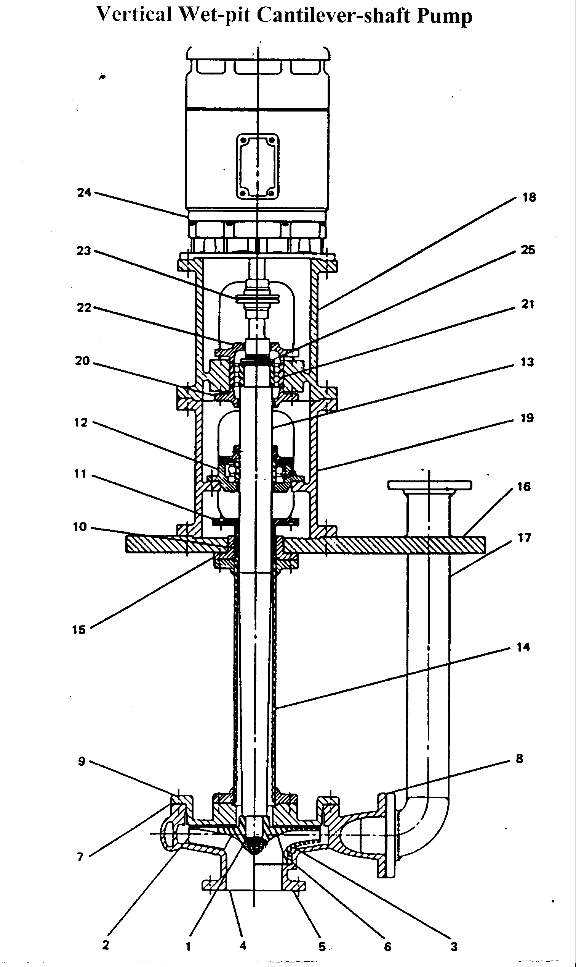

Vertical wet-pit cantilever-type volute Pump: (1) impeller nut, (2) open impeller, (3) closed impeller. (4) open casing. (5) closed casing, (6) casing wearing ring. (7) casing gasket, (8) discharge flange gasket, (9) back cover, (10) packing, (11) packing gland, (12) radial bearing. (13) shaft, (14) supporting pipe, (15) sep arate stuffing box, (16) sump cover, (17) discharge pipe. (18) upper motor pedestal. (19) lower motor pedestal.(20) lower thrust bearing cover, (21) thrust bearing, (22) upper thrust bearing cover, (23) coupling, (24) motor, (25) bearing locknut and washer. (Laurence Pump & Engine)

5 – Training Aids

- White board.
- Projector.
- Transparencies.

Transparencies

T | Description | Page
T₁ | Course objectives | 5
T₂ | Common vertical turbine pumps | 12
T₃ | Mixed flow bowl assembly | 14
T₄ | Can turbine drawing assembly | 17
T₅ | Submersible & propeller pumps | 20
T₆ | Propeller pump impellers & bowl assembly | 22
T₇ | Propeller bowl assembly & thrust ring | 23
T₈ | Pressing graphalloy bearing | 25
T₉ | Solid shaft run outs & types of impeller | 30
T₁₀ | Effect of rising semi open impellers | 33
T₁₁ | Hollow shaft driver adjustment & clutch assembly | 34
T₁₂ | Hollow shaft coupling ratchet | 35
T₁₃ | Solid shaft coupling & spacer | 36
T₁₄ | Bowl assembly- with semi-open impeller | 41
T₁₅ | Impeller thrust ring design | 42
T₁₆ | Trouble shooting chart | 43
T₁₇ | Pump performance curve | 44
T₁₈ | Vertical wet-pit cantilever type volute pump | 46

6- Lesson Plan

Lesson Plan
Lesson –I: Vertical Turbine Pumps and Propeller Pumps

Objectives:
- Understand the principle of operation.
- Understand vertical turbine pump components.
- Understand can turbine pump components.
- Understand propeller turbine pump components.
- Understand types of bearings and wear rings.

Content | Activity
Course Introduction  - A. Common classification of pumps  - Vertical turbine pumps description.  - Can turbine pumps.  1.2.3 can turbine pump description  1.2.4 V.C.P adjustments.  - Axial adjustment.  - Impeller adjustment.  - Submersible turbine pumps.  B. Pumps classification due to the  flow pattern.  - Mixed flow.  - Axial flow.  - Propeller turbine pumps.  - Bearings.  - Wear rings.  - Lesson briefing.  - Discussion.  - Assessment. | Show T₁ for course objectives  Show T₂  Show T₃  Show T₄  Show T₅ page 20  Show T₅ & T₆ & T₇  Show T₈  Main topics.

Assessment

Lesson One Assessment:

- What are the types of vertical turbine pumps?
- What are the major parts of the line shaft turbine pump?
- What is the effect of increasing the number of bowels in vertical turbine pumps?
- What is the main factor which influence the pump capacity?
- Describe the arrangement of hollow shaft motors?
- Identify the most common bearings used in the hollow shaft motors.
- What is the main function of the hollow shaft motor arrangement?
- What are the main reasons for the vertical can pump design?
- Where is the best location for the pump shaft during normal operation?
- What are the advantages and disadvantages of submersible pumps?
- What is the main purpose of propeller pumps?
- Explain how to press a graphalloy bearing in a bowl.

Lesson Plan

Lesson –II: Impeller Adjustment For Vertical Turbine Pumps

Objectives:
- Perform driver alignment.
- Understand impeller adjustment for hollow shaft driver.
- Perform impeller adjustment for solid shaft driver.

Content | Activity
- 2- Impeller adjustment  - Driver types.  - Driver alignment.  - Impeller adjustment-  general.  - Enclosed impeller.  - Semi-open impeller.  2.4 Re-adjustment chart  2.5.1 Hollow shaft driver, impeller  adjustment.  2.5.2 Hollow shaft driver, reverse  clutch.  2.5.3 Hollow shaft driver, non-  reverse ratchet.  2.6 Solid shaft driver, impeller  adjustment.  - Guide participants to work shop.  - Lesson briefing.  - Discussion.  - Assessment. | Show T₉  Show T₉  Show T₁₀  Show T₁₁  Show T₁₁  Show T₁₂  Show T₁₃ page 36  Demonstrate the above impeller adjustments.

Assessment

Lesson Two Assessment

- What does the hollow shaft driver means?
- What does the solid shaft driver means?
- How can you perform the solid shaft driver alignment?
- Explain the enclosed impeller adjustment.
- Explain the semi-open impeller adjustment for hollow shaft drive.
- How can you readjust a semi-open impeller to get a 600 ft discharge head if the pump column is 30 ft?
- Mention the procedure of the hollow shaft driver impeller adjustment.
- Mention the procedure of the solid shaft driver impeller adjustment in the case of coupling spacer.

Lesson Plan

Lesson –III: vertical turbine pump maintenance

Objectives:
- Perform assembly and disassembly.
- Demonstrate assembly and disassembly for a volute pump.
- Understand trouble shooting.
- Understand pump per performance.

Content | Activity
- 3. Vertical turbine pump.  - Bowl assembly.  - Column assembly.  - Discharge heat assembly.  - Installation and maintenance.  - Vertical turbine pump repairs (assembly and disassembly)  - Impeller assembly methods.  - Trouble shooting pump performance curve.  - Vertical wet-pit cantilever volute pump.  - Guide participants to workshop.  - Discussion.  - Lesson briefing,.  - Assessment | Show T₁₄  Show T₁₄  Show T₁₄  Show T₁₆  Show T₁₇  Show T₁₈  Demonstrate the assembly disassembly.

Assessment

Lesson Three Assessment

- How are impellers locked on to the bowl shaft?
- What are the bearing materials for the bowl and suction case?
- What is the bowl shaft projection measurement, which is to be verified during assembly?
- How can you measure the bowl shaft endplay during assembly?
- What is the function of protecting collar in the suction case?
- On the performance curve, what is the maximum capacity of the pump?
- What are the causes of reduced capacity of the vertical turbine pump?
- What are the causes of high vibration and noise in the vertical turbine pump?
- Practical Exercise:
Perform disassembly and assembly on the “Johnston” vertical turbine pump at the training center.
10- Practical Exercise:
Perform disassembly and assembly on the vertical wet-pit cantilever pump at the training center.

Assessment
Final Assessment (Classroom)

- What s the function of the bowl in vertical turbine pump?
- What is the result if the number of bowls the double?
- What are the advantages of vertical can pump?
- Describe the semi-open impeller adjustment for hollow shaft drive.
- What is the required adjustment for semi-open impeller on hollow shaft drive if discharge head = 700 feet and pump column = 40 feet?
- How can you adjust the enclosed impeller pump?
- Identify the parts names on the attached drawing for the vertical turbine pump bowl assembly with semi-open impeller.

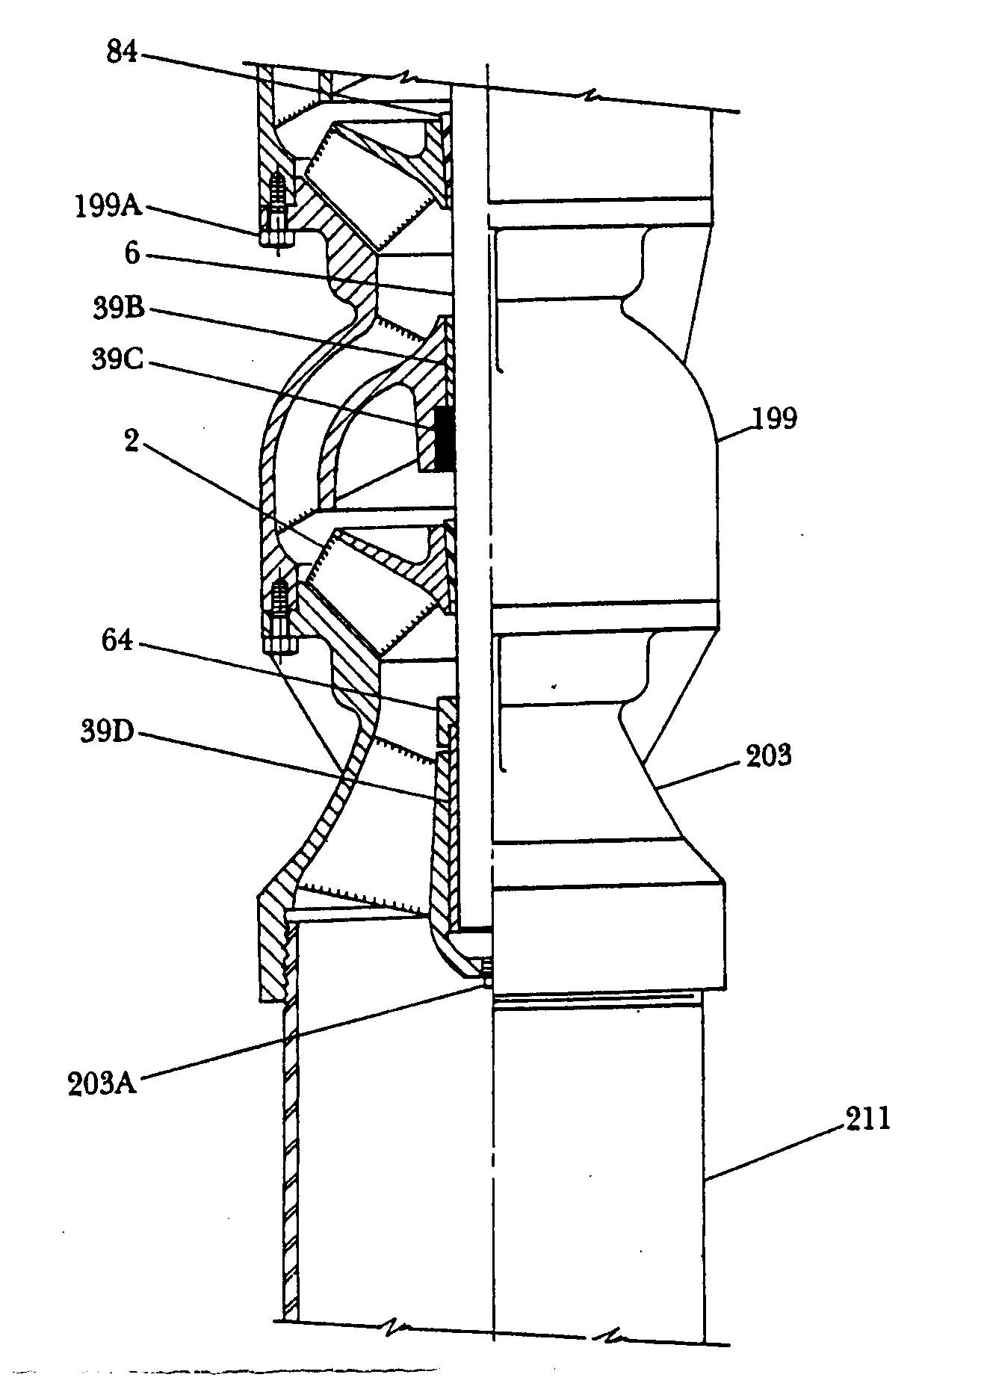

Answers

Lesson One Answers:

- a. Line shaft turbine pumps.
b. Can turbine pumps.
c. Submersible turbine pumps.
d. Propeller turbine pumps.
2- a. The pumping unit (Bowl assembly).
b. The water column.
c. The discharge head.
d. The motor or drive unit.
3- Increasing the number of bowls will increase the discharge fluid pressure.
If one bowl produces 50 PSI. then two bowls will produce 100 PSI, and three will produce 150 PSI.
4- The main factor is the first impeller on the suction side. The capability of the first impeller determines the amount of the pumped fluid.
5- In the hollow shaft motors, the pump drive shaft passes through the motor shaft and is secured to the top of the motor by the head nut.
6- The top bearing is a thrust bearing and is often a spherical-roller thrust bearing. This bearing bears the entire load of the drive shaft and impellers.
The bottom bearing is a radial bearing, and usually a single-row deep groove ball bearing.
7-The hollow shaft motor arrangement, with semi-open impellers can alter the
pump capacity and discharge pressure. This purpose can be achieved by adjusting the pump shaft up or down.
8- The vertical can pump (VCP) is designed to minimize the axial thrust, there
by permitting the use of an in-line motor.
The mechanical seal can be removed without removing the driver through
the spacer space.
It can develop higher pressure according to the suction pressure in the can.
9- The pump shaft proper location is the mid-distance of the shaft end play.
10- Advantage:
- The motor is located under the pump, and both under the fluid. so
that the motor is cooled properly.
- No discharge columns and consequently no bearings.
- Disadvantages:
- The motor may fail if the fluid enters.
- No impeller adjustment clearance as with the line shaft turbine (vertical turbine pumps).
11- Deliver a high volume at low head. Its application is for sewing and slurry.
12- Using arbor press or hydraulic press or bolt and nut, keeping the pressure
continuously until finished.

Answers

Lesson two Answers:

- Hollow shaft driver is the motor in which the motor shaft is a hollow tube, and the pump shaft extends through it, and connected to it by a clutch assembly at the top of the driver. It provides an axial adjustment for the pump impeller.
- Solid shaft driver is the motor in which rotor shaft project below the driver mounting base. It require an adjust able coupling with the pump.
- A. On the motor base, dial indicator anvil will measure:-
- Driver rabbit fit, concentricity within .002” per feet of rabbit fit diameter.
- Mounting face, squareness wither .002” per feet of rabbit fit diameter.
B. On the shaft, dial indicator anvil will measure:-
- Run out within .002”.
- Squareness of split ring groove within .002”
- Shaft end float within .005”
- Enclosed impeller adjustment. The shaft should be raised 1 ½ to 2 turns of the adjusting nut or approxiamtely1/8”
- Semi- open impeller adjustment:
- Be sure that the impeller are down against the bowl seat.
- Tight the top drive nut to raise impeller to the required lift.
- Lock the nut using locking screws.
- The adjustment should be as follows:-
.015” + .005” for each 100 feet of discharge head + .005” for each 10 feet of column assembly = .015” + .005” × 6 +.005” × 3 = .060”
- 1. Install head shaft, driver clutch and gib key.
2. Be sure that impellers are “on bottom” at its seat.
3. Adjust impeller by tightening the head nut at the required value.
- Lock head shaft nut with lock screws.
- 1. Back adjusting nut until the nut bears firmly against the spacer.
2. This will insure that impellers are down against their seat.
3. Thread adjusting nut down until impellers are just lifted of their seat and the shaft will rotate freely.
- Lock adjusting nut using lock screws thru threaded holes inside pump half coupling and into hole drilled in side of adjusting nut.
- Adjusting nut may have to be turned slightly to line up holes.

Answers

Lesson Three Answers

- By either the lock collet or thrust ring.
- Bowel bearings are high lead bronze and rubber. Suction case bearings are extra-long high-lead bronze packed with waterproof grease.
- The distance from the column seat to the top of the bowl shaft, when the impellers are seated against the suction case.
- Remove the shaft stop at the suction end, measure the lateral travel of the shaft, this movement is the endplay. Re-lock the shaft again.
- To protect the suction case bearing from the abrasive materials.
- The maximum capacity is 4000 gallons per minute and the total discharge head is 150 feet at maximum efficiency 80 %
- 1- By pass open
- Lift too high.
- Low motor speed
- Strainer or impeller partly plugged.
- Scaled or corroded pipe or leaks in system.
- Air or gas in the system.
- Excessive wear due to the abrasives.
- Impellers not properly adjusted.
- Impellers loose on shaft.

- 1- Unit running back ward.
2- Air in the system.
3- Loose fasteners.
4- Badly worn bearing for the pump or motor.
5- Impeller loose on shaft.
6- Coupling misalignment.
7- Pipe strain.

Answers

Final Assessment Answers

- The bowl serve as the volute of an end- suction centrifugal pump. The pumped fluid path around the impeller increase in area, so, the velocity converted into pressure.
- The discharge pressure will be double.
- 1. Minimize the axial thrust, so solids shaft motor can be used.
2. Mechanical seal can be removed without removing the motor.
3. Develop higher pressure, according to suction pressure.
4. 1. Impellers should touch the bottom seat.
2. tight top drive nut to raise the impellers to the required adjustment.
3. Lock the nut with locking screws.
5. The adjustment = .015” + .005” × 7 + .005” × 4 = .070”
6. Enclosed impeller should be raised 1 ½ to 2 turns of the adjusting nut or
approximately 1/8”.
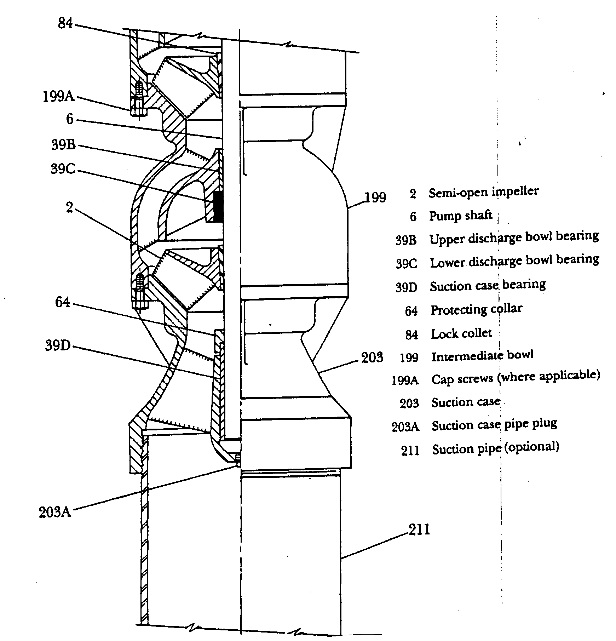
7.

Final Assessment (Workshop)

- Perform impeller adjustment on the vertical turbine pump (Johston type).
- Perform disassembly and assembly for the vertical turbine pump(Johston type).
- Demonstrate disassembly and assembly for the vertical wet-pit cantilever, volute type pump.

